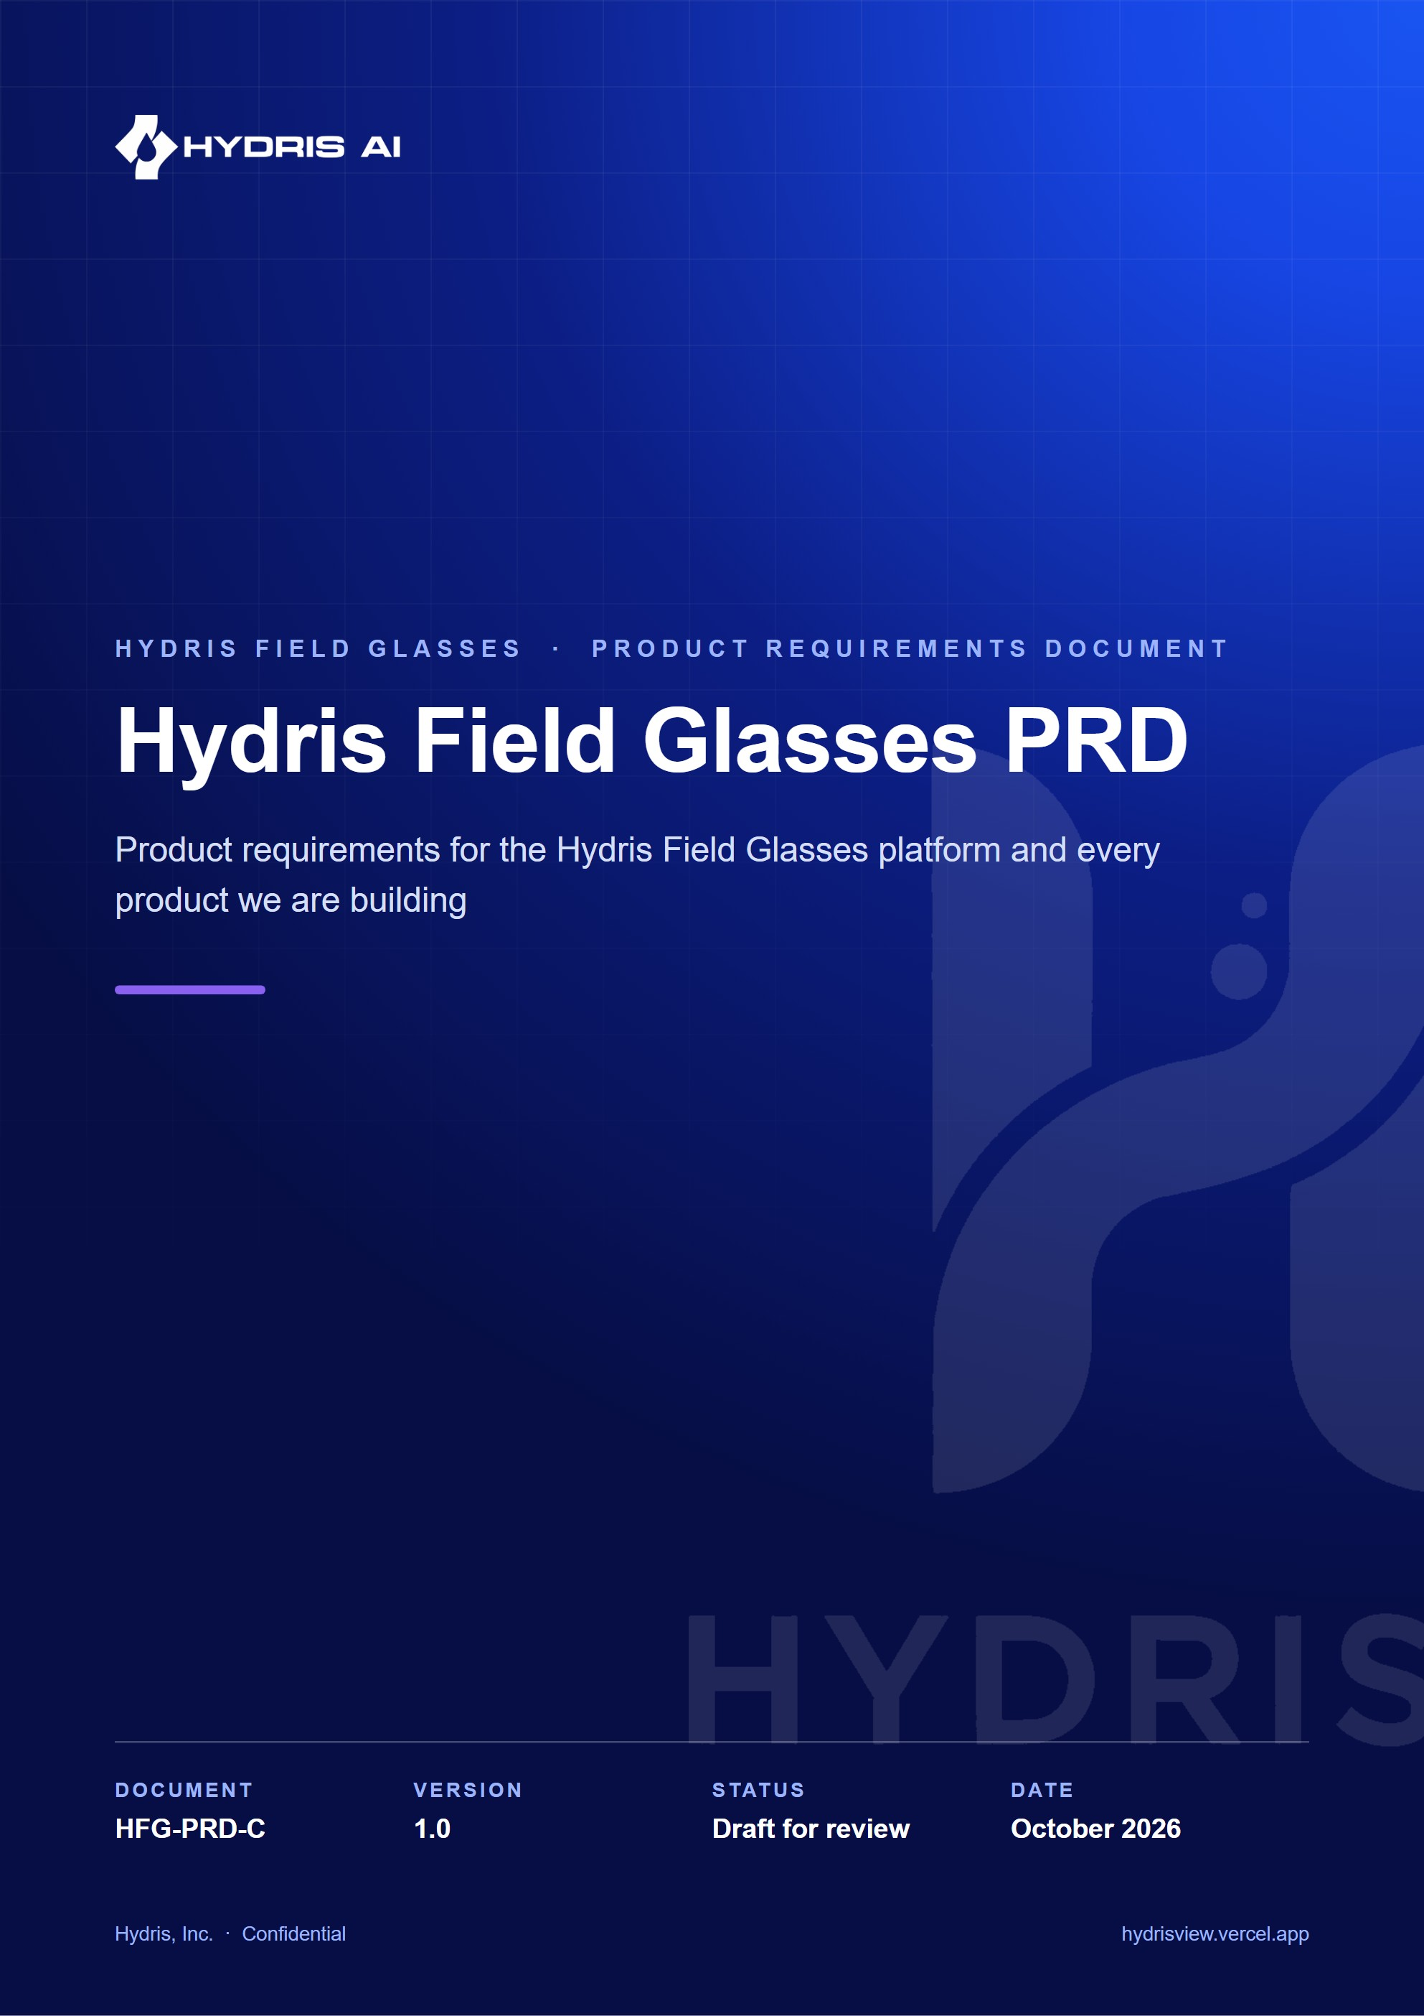
Document control
Document | Hydris Field Glasses PRD (HFG-PRD-C)
Version | 1.0
Status | Draft for review
Owner | Product and engineering, Hydris
Audience | Leadership, product, engineering, design, partners and pilot customers
Product | Hydris Field Glasses: website, operator console, glasses app, Android app, API
Source of truth | docs/product/_prd.md in tarun-km/hydrisview (this Word file is generated from it)
Classification | Confidential: Hydris, Inc. and named partners
Revision history
Version | Date | Author | Changes
1.0 | October 2026 | Product and engineering, Hydris | Concise PRD edition

Contents
1 Overview 6
1.1 Executive summary 6
1.2 Problem statement 6
1.3 Opportunity and market context 7
1.4 Vision 8
1.5 Product principles 8
2 Goals, non-goals and success metrics 9
2.1 Business and user goals 9
2.2 Non-goals 9
2.3 North-star metric 9
2.4 KPI table 10
3 Users and use cases 11
3.1 Personas 11
3.2 Top use cases 11
3.3 Operator-day journey 12
4 Solution overview 13
4.1 The product family 13
4.2 System context 14
4.3 The core loops 14
4.4 Release scope by product 15
5 Operator console 16
5.1 Overview 16
5.2 Users and user stories 16
5.3 Scope 17
5.4 Overview dashboard 17
5.5 Plant model and map 17
5.6 Telemetry 18
5.7 Alarms 18
5.8 Inspections and maintenance 18
5.9 Documents and SOPs 18
5.10 Glasses fleet and UI profiles 18
5.11 Audit review and approval 18
5.12 Reports 19
5.13 Administration and roles 19
5.14 Functional requirements 19
5.15 Key flows 21
5.16 Acceptance criteria 23
5.17 Success metrics 23
5.18 Dependencies and open issues 24
6 Website and demo 25
6.1 Overview 25
6.2 Users and user stories 25
6.3 Scope 25
6.4 Functional requirements 25
6.5 Key flows 26
6.6 Acceptance criteria 26
6.7 Success metrics 26
6.8 Dependencies and open issues 27
7 Glasses app 28
7.1 Overview 28
7.2 Users and user stories 28
7.3 Scope 28
7.4 Runtimes 28
7.5 Pairing 29
7.6 Inspections with offline replay 29
7.7 UI profiles 29
7.8 Functional requirements 29
7.9 Key flows 30
7.10 Acceptance criteria 31
7.11 Success metrics 31
7.12 Dependencies and open issues 31
8 Hydris Field Android app 32
8.1 Overview 32
8.2 Users and user stories 32
8.3 Scope 32
8.4 Functional requirements 33
8.5 Key flows 33
8.6 Acceptance criteria 34
8.7 Success metrics 34
8.8 Dependencies and open issues 35
9 Ray-Ban Meta integration 36
9.1 Overview 36
9.2 Users and user stories 36
9.3 Scope 36
9.4 Meta AI app dependency and DAT lifecycle 36
9.5 Registration 37
9.6 Functional requirements 37
9.7 Key flows 37
9.8 Acceptance criteria 38
9.9 Success metrics 39
9.10 Dependencies and open issues 39
10 Audit document scanning 40
10.1 Overview 40
10.2 Users and user stories 40
10.3 Scope 40
10.4 Functional requirements 40
10.5 Key flows 41
10.6 Acceptance criteria 42
10.7 Success metrics 43
10.8 Dependencies and open issues 43
11 Hey Hydris voice assistant 44
11.1 Overview 44
11.2 Users and user stories 44
11.3 Scope 44
11.4 Functional requirements 44
11.5 Key flows 45
11.6 Acceptance criteria 45
11.7 Success metrics 45
11.8 Dependencies and open issues 46
12 Platform, data and integrations 47
12.1 Architecture summary 47
12.2 Tenancy and security requirements 47
12.3 Data entities summary 48
12.4 APIs and integrations 48
12.5 AI services with a human in the loop 49
12.6 Platform requirements 50
13 Non-functional requirements 51
14 Release plan and milestones 53
14.1 Phase entry and exit criteria 53
14.2 Pilot exit criteria 54
15 Dependencies, assumptions and constraints 55
16 Risks and mitigations 56
17 Open questions and decisions 58
18 Appendix 59
18.1 Glossary 59
18.2 Related documents 59

1 Overview

1.1 Executive summary
Wastewater operators spend their shift walking the plant: reading instruments, checking pumps and blowers, sampling effluent, writing values on paper logs and responding to alarms that usually reach the control room before they reach the person standing next to the equipment. The records they produce are the evidence a plant shows its regulator, and much of that evidence is still paper.
Hydris Field Glasses puts the live state of the plant, the next task and the approved procedure in the operator's line of sight, hands free, and turns every reading, check and paper record they touch into a trustworthy digital record. It is one platform with eight products (website and demo, operator console, glasses app, Hydris Field Android, Ray-Ban Meta integration, audit scanning, voice assistant, platform API and data) that share one API, one tenant model and one permission matrix.
The platform core is Built and running at https://hydrisview.vercel.app in demo mode on synthetic plant data. The Android app and the Ray-Ban Meta paths are Partial: built in code, not yet validated on physical glasses. This PRD asks leadership to approve three things: the pilot scope (one or two Indian ETPs or STPs in Q1 2027), the hardening work that must land before it, and the success metrics the pilot will be judged on.
8  products  one API, one tenant model |  | 143  API routes  15 modules in apps/api/src/modules |  | 67  automated tests passing  26 domain + 41 API, local run, 22 Oct 2026 |  | Q1 2027  customer pilot  target, one or two Indian plants

DECISION
Hydris is read-only towards the plant. It never writes to PLCs, SCADA or equipment, and every assistant tool is read-only (apps/api/src/modules/voice-assistant.ts). This keeps Hydris outside the plant's control-system safety case and is a precondition for every requirement in this document.

1.2 Problem statement
Effluent, sewage, water and common effluent treatment plants (ETPs, STPs, WTPs and CETPs) run continuously, with shift operators walking fixed rounds through intake, aeration, clarification, disinfection, sludge handling and the discharge point. Four problems recur:
- Paper rounds drift from reality. Readings are written on clipboards and transcribed later. Nobody can tell which value was observed and which was copied.
- Alarms reach the wrong person. The operator nearest the pump finds out last, and "acknowledged" gets confused with "fixed", so the record shows alarms cleared that were never resolved.
- Compliance evidence is unsearchable. Logbooks, lab sheets and checklists are paper. Producing evidence for an inspection means digging through files.
- Phones are the wrong tool at the asset. Gloves, ladders, wet hands and sampling bottles make phones awkward, and there is no industrial software for smart glasses.
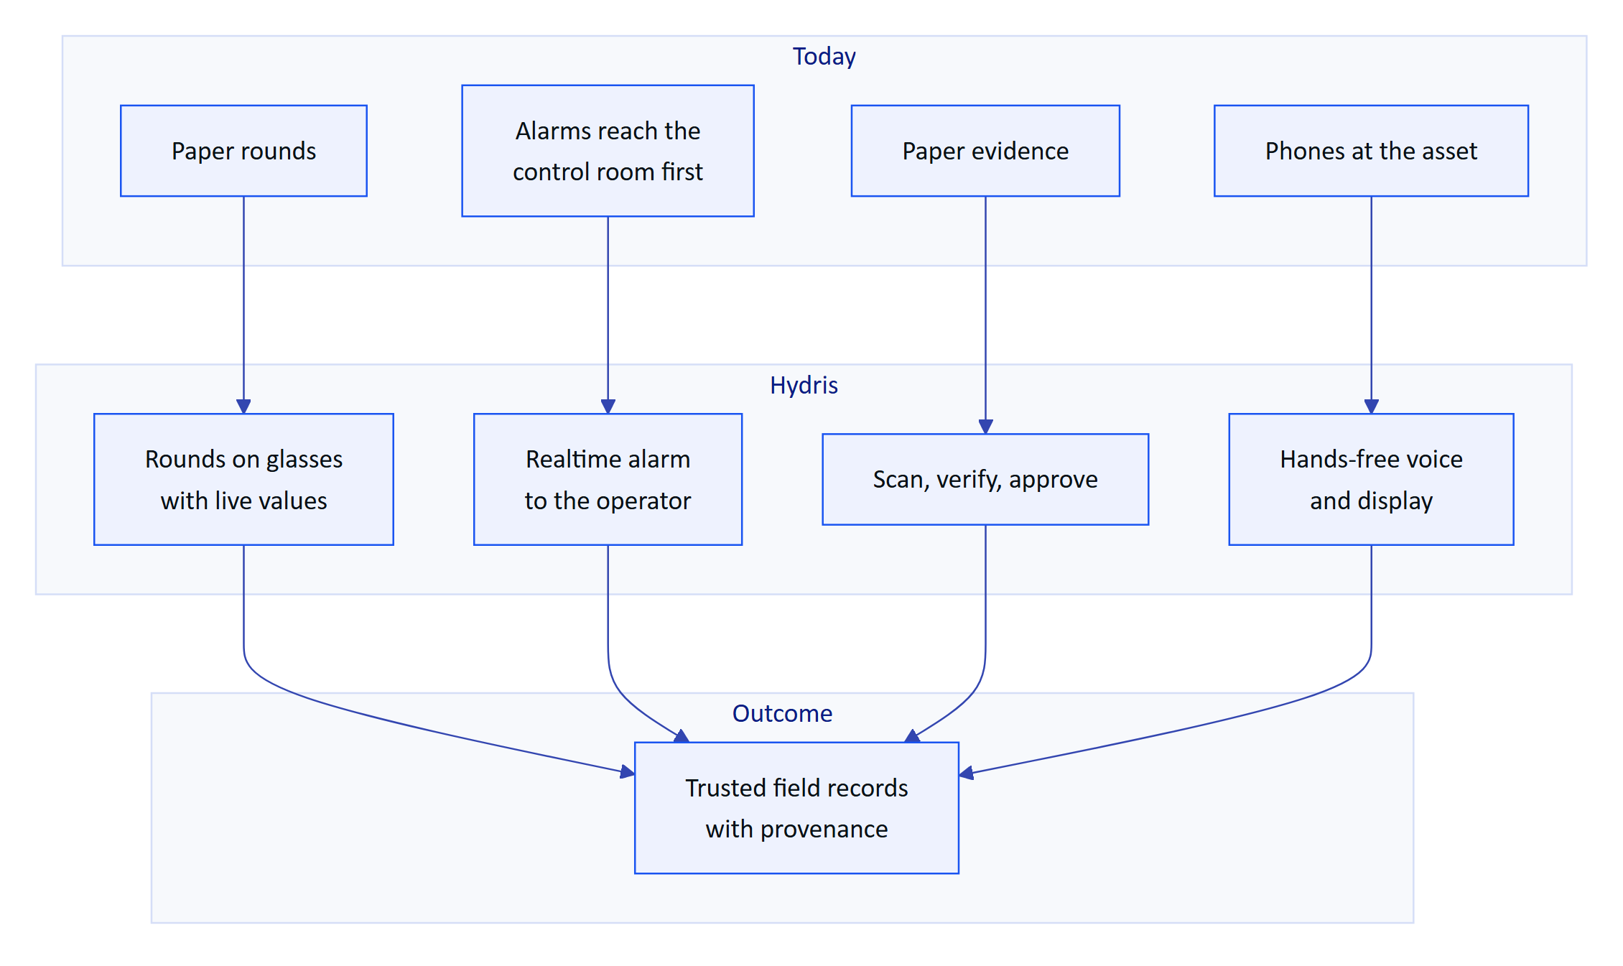
Figure 1. From today's problems to the outcomes Hydris targets

1.3 Opportunity and market context
Hydris is designed first for India, where discharge monitoring is a legal obligation and record quality matters:
- Discharges are regulated under the Water (Prevention and Control of Pollution) Act, 1974, through consents to establish and operate issued by State Pollution Control Boards (SPCBs) and Pollution Control Committees.
- General discharge standards are set under the Environment (Protection) Rules, 1986, with plant-specific limits in each consent.
- In 2014 the Central Pollution Control Board (CPCB) directed the 17 categories of highly polluting industries, and CETPs, to install online continuous effluent and emission monitoring systems (OCEMS) connected to CPCB and SPCB servers.
The same need (continuous monitoring, retrievable records, who did what and when) exists under NPDES permits in the United States and the Urban Waste Water Treatment Directive in the EU, which makes those later markets.
Three things make this the right time. Ray-Ban Meta camera glasses are light, affordable and acceptable on a plant floor. Meta's Wearables Device Access Toolkit (DAT 1.0.1) lets third-party Android apps use the glasses' camera, microphone, capture button and speakers. Language models can now answer spoken questions from structured plant data well enough to be useful, provided they are grounded and constrained.
Table 1. Alternatives a plant uses today and the gap Hydris fills
Alternative | Strength | Gap Hydris fills
Paper logbooks | Familiar, no devices | No provenance, no search, transcription errors
SCADA and HMI | Authoritative live data | Not at the asset; no rounds or paper digitization
Mobile forms apps | Cheap digital checklists | Not hands-free; no live context or alarm lifecycle
Remote-assist glasses apps | Expert sees what the operator sees | No plant data model, rounds or records
CMMS and EAM suites | Maintenance planning | Desktop-first, weak in the field, no glasses

NOTE
Hydris is not a certified OCEMS and does not replace OCEMS reporting to CPCB or SPCB servers. A plant's OCEMS analyzers can feed Hydris through the gateway ingestion API (FR-022) so operators see the same values the regulator sees.

1.4 Vision
Every operator in a water or wastewater plant sees what matters, does the next right thing, and leaves behind a record that stands up to an audit, without putting down their tools.
In three years we want Hydris to be the default way an Indian ETP, STP or CETP runs its rounds, responds to alarms and keeps its compliance records, and a credible choice in other markets with similar discharge-monitoring obligations.

1.5 Product principles
These principles settle design arguments. When two requirements conflict, the higher principle wins.
Table 2. Product principles and how the product applies them
ID | Principle | What it means in practice
P1 | Safety first, read-only towards the plant | Never issue a control command; point to the approved procedure and the supervisor
P2 | Never show a guess as a value | Missing data is "no data", never zero; stale values are marked and excluded from roll-ups
P3 | Every number has provenance | A reading states its source (instrument, manual, lab, simulator) and time
P4 | History is never overwritten | Corrections append; the original stays visible
P5 | Humans verify, machines assist | AI and OCR propose, a person confirms, a different person approves
P6 | Glance, then act | One question per glasses screen; spoken answers of one or two sentences
P7 | Hands busy, still in control | Every action works with directional input or voice; the camera runs only on intent
P8 | Isolation enforced by the database | Row-level security on every tenant table
P9 | Synthetic data never reaches a customer | Simulator readings are refused for non-demo organizations
P10 | One account everywhere | Same user, permissions and data on console, glasses and phone

2 Goals, non-goals and success metrics

2.1 Business and user goals
Table 3. Goals for the pilot and general availability
ID | Type | Goal | Evidence of success
G1 | Business | Win a paid pilot at one or two Indian plants in Q1 2027 | Signed pilot contract and customer sign-off at exit
G2 | Business | Reach general availability in Q2 2027 | Store or MDM release approved; security review passed
G3 | User | Operators record rounds faster and more accurately than on paper | Time per inspection 30 % below the paper baseline (target)
G4 | User | The right person acts on an alarm quickly, and closes it properly | Median time to acknowledge under 5 minutes for critical and high (target)
G5 | User | Paper records become verified, searchable evidence | Median capture to approval under 24 hours (target)
G6 | Trust | No answer or record presents a guess as a fact | Zero hallucinated numbers; zero cross-tenant incidents

2.2 Non-goals
- Plant control. No writes to PLC, SCADA or equipment, and no setpoint changes.
- A SCADA, DCS or historian. Hydris reads from them (connectors Planned) and never replaces them.
- Certified regulatory reporting. No certified OCEMS reporting to CPCB or SPCB servers.
- A general chatbot. The assistant answers only from the tenant's own data and approved documents, never the open internet.
- Autonomous decisions. AI never approves a record or generates a procedure on its own.
- A LIMS or CMMS. Lab results are stored as telemetry with source = lab; integrations come later.
- Custom hardware or iOS before GA. The pilot runs on Ray-Ban Meta through Android.
- Self-serve signup for customer tenants. Self-serve exists only in demo mode.

2.3 North-star metric
Verified field records per active operator per week: inspections submitted, alarms acknowledged within target and audit documents approved, divided by the operators who used Hydris that week. It rises only when operators use the product in the field and the records it produces are trusted.
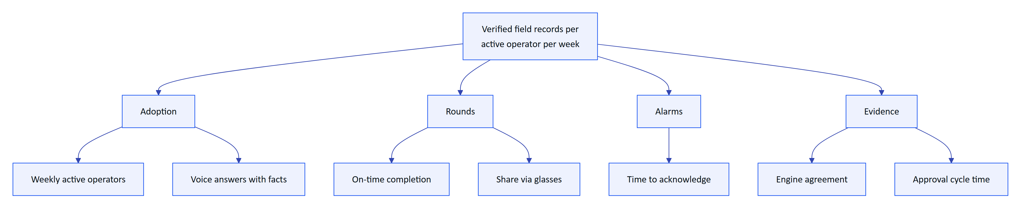
Figure 2. KPI tree: the north star and the input metrics that drive it

2.4 KPI table
All values below are pilot targets, not measurements. Most have a data source today in /reports/:kind (apps/api/src/modules/insights.ts); voice and agreement metrics need lightweight logging that is Planned for the pilot (NFR-034).
Table 4. KPIs with definitions, pilot targets and measurement
Metric | Definition | Target | Measurement
Weekly active operators | Operators with at least one record in a week, over licensed operators | 70 % or more | Inspections and alarms reports
On-time rounds | Inspections submitted by their due time | 95 % or more | onTimeRate, inspections report
Time per inspection | Median start to submit versus paper baseline | 30 % lower | Inspections report plus baseline study
Share via glasses | Inspections submitted from glasses | 50 % or more | viaGlasses, inspections report
Time to acknowledge | Median minutes, critical and high alarms | Under 5 minutes | medianMinutesToAcknowledge
Engine agreement | Average agreement score of approved documents | 90 % or more | Audit document agreement score
Reviewer edits | Corrected fields over reviewed fields | Under 5 % | Audit document review data
Approval cycle | Capture to approval, median | Under 24 hours | Audit document timestamps
Voice answered with facts | Questions with a known intent | 85 % or more | Intent logging (Planned)
Hallucinated numbers | Numbers in answers absent from facts | 0 | Automated check on logged answers
Cross-tenant incidents | Confirmed exposure across tenants | 0 | Security incident log
Device revocation time | Revoke to session.ended on the stream | 30 s or less | Realtime event timestamps

3 Users and use cases

3.1 Personas
Six personas map one to one onto the roles in packages/domain/src/roles.ts (6 roles, 38 permissions); the Hydris platform admin is a flag on the user.
Table 5. Personas, goals, pain points and primary surface
Persona | Role | Goals | Pain points | Primary surface
Field operator (Ravi) | field_operator | Next task, live values at the asset, record readings, acknowledge alarms | Gloves and wet hands, copied readings, blamed for others' values | Glasses, Android app
Shift supervisor (Meena) | supervisor | Dispatch rounds, triage alarms, review inspections, verify scans | Cannot see late rounds or who owns an alarm | Console, Android app
Maintenance engineer (Arjun) | maintenance_engineer | Work orders, checklists, resolve alarms, SOPs at the asset | Manuals and history are in the office, not at the pump | Android app, glasses
Plant manager (Priya) | factory_manager | KPIs, alarm rules, approve documents, control glasses features | Accountable to the SPCB with paper evidence | Console
Compliance auditor (Mr Rao) | viewer plus report.read | Tamper-evident trail, approved records, exports | Cannot trace who changed what and when | Console, PDF exports
Organization admin | org_admin | Members, invitations, sites, glasses UI profiles | Device onboarding and revocation take too long | Console

3.2 Top use cases
Table 6. Top use cases and the requirements that serve them
ID | Use case | Served by | Status
J1 | Start a round with assigned inspections in order | FR-040, FR-041, FR-059 | Built on glasses; Android Planned (FR-044)
J2 | See live readings and their freshness at the asset | FR-021, FR-026, FR-095 | Built
J3 | Acknowledge a nearby alarm and see the action and SOP | FR-031, FR-032, FR-033, FR-112 | Built
J4 | Capture a paper log once and get it verified and approved | FR-060 to FR-069 | Built
J5 | Ask by voice and hear a short, grounded answer | FR-071, FR-072, FR-074 | Built (English); glasses mic Partial
J6 | Control what each role sees on the glasses without an app update | FR-054 | Built
J7 | Pair, reassign, suspend or revoke glasses in seconds | FR-050 to FR-053, FR-057 | Built; DAT registration Partial
J8 | Trace every approved document and change to a person and time | FR-065, FR-066, FR-082 | Built
J9 | Try the product in minutes without talking to sales | FR-083, FR-091, FR-102 | Built

3.3 Operator-day journey
The journey below is the target state for a field operator across one shift. Scores (1 to 5) are design targets, not measurements.
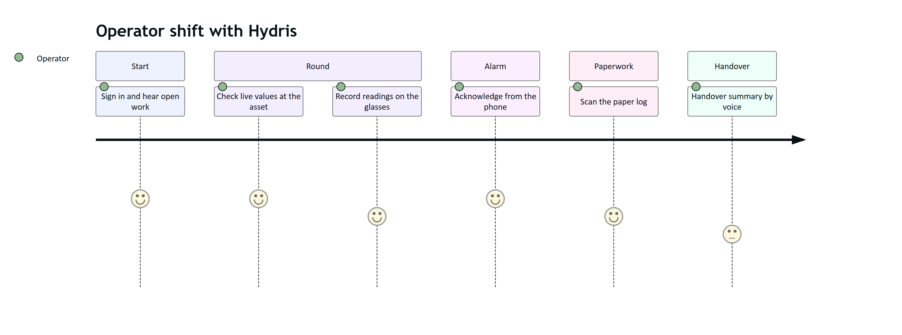
Figure 3. Field operator journey across one shift (target state)
The product is strongest today at alarm acknowledgement, scanning and voice lookups. The weakest step is handover: the handover summary (FR-122) is Planned, and inspection execution on the Android app (FR-044) is Planned, so rounds run in the glasses app today.

4 Solution overview

4.1 The product family
Hydris is one platform with eight products. A user signs in once and gets the same permissions and data on the console, the glasses and the phone. Every product talks to one API, and the database, not application code, enforces tenant isolation.
Table 7. The product family, sub-products, users and status
Product | Sub-products | Primary users | Status
Website and demo | Seven public pages, contact and demo request, live glasses demo, named demo accounts | Prospects | Built
Operator console | Telemetry, alarms, inspections and maintenance, plant map, devices and UI profiles, audit documents, documents and SOPs, reports, admin | Supervisors, managers, auditors, admins | Built
Glasses app | Twelve heads-up screens, phone layout, browser simulator, offline inspection queue | Field operators, engineers | Built (web); native display rendering Planned
Hydris Field Android | Sign-in, home, work, alarms, sensors, audit scan with on-device OCR, "Hey Hydris", glasses connection | Field operators, supervisors, engineers | Partial: built in code, glasses paths not validated on hardware
Ray-Ban Meta integration | Camera, capture button, microphone and speakers through DAT 1.0.1; registration as a Hydris device | Field operators | Partial: not validated on physical glasses
Audit scanning | Guided A4 capture, dual OCR, optional vision engine, field review, four-eyes approval, searchable PDF | Operators, supervisors, managers, auditors | Built
Voice assistant | Wake phrase, read-only tools, short spoken answers, rules fallback | Field operators, engineers | Built (English); other languages Planned
Platform API and data | 143 routes, row-level security, realtime events, append-only audit trail, demo mode | All products | Built

4.2 System context
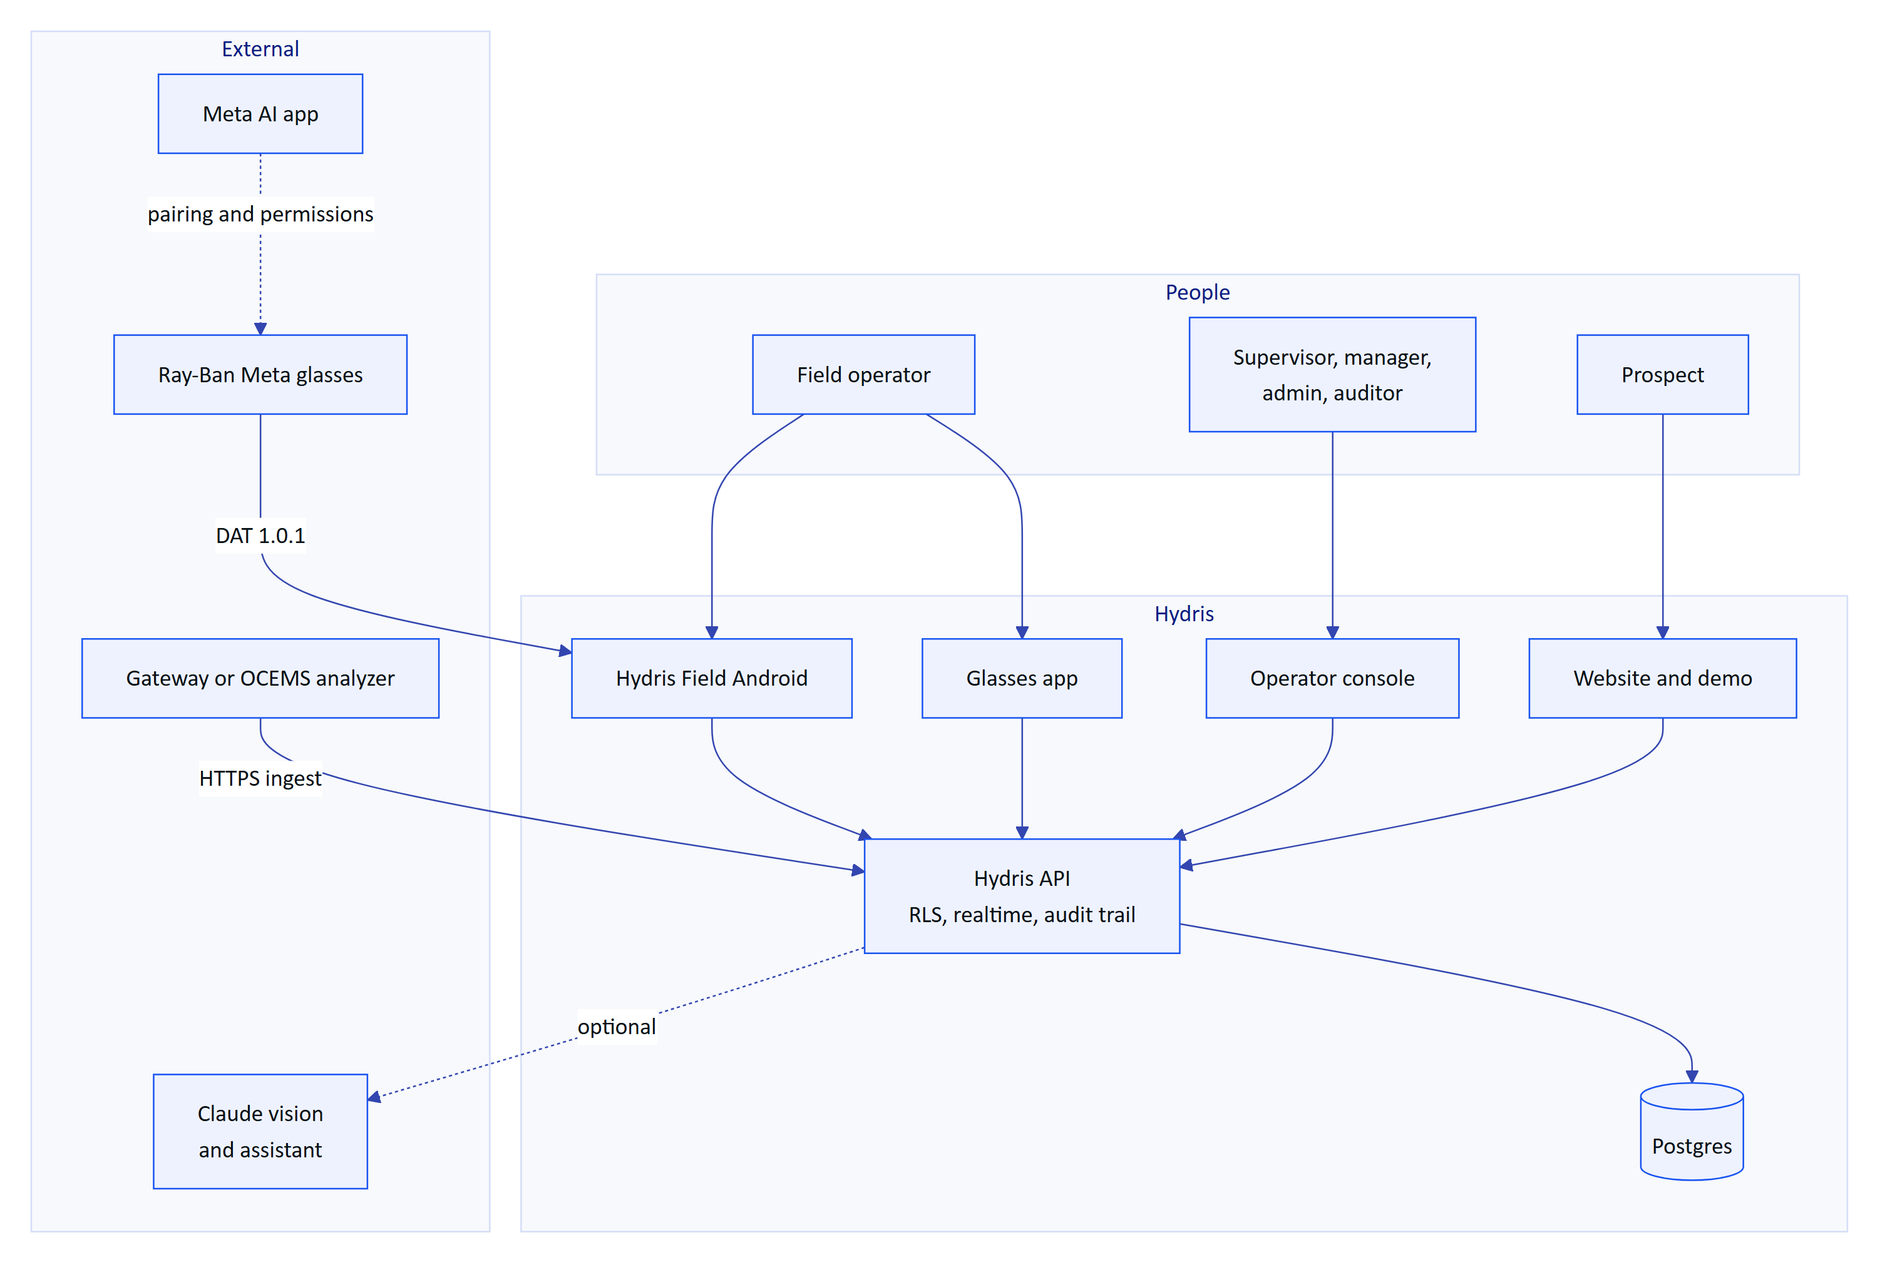
Figure 4. System context: people, Hydris products and external systems
Three external dependencies shape the design. Ray-Ban Meta glasses reach third-party apps only through DAT, and they are paired and permissioned through the Meta AI app, which must stay installed on every operator phone. Plant data arrives over HTTPS from an edge gateway or OCEMS analyzer (FR-022); MQTT and OPC UA adapters are Planned. The Claude model is optional: without it, a rules engine answers questions and OCR alone extracts documents (NFR-037).

4.3 The core loops
Four loops explain the whole product. Each crosses several products, which is why they share one platform.
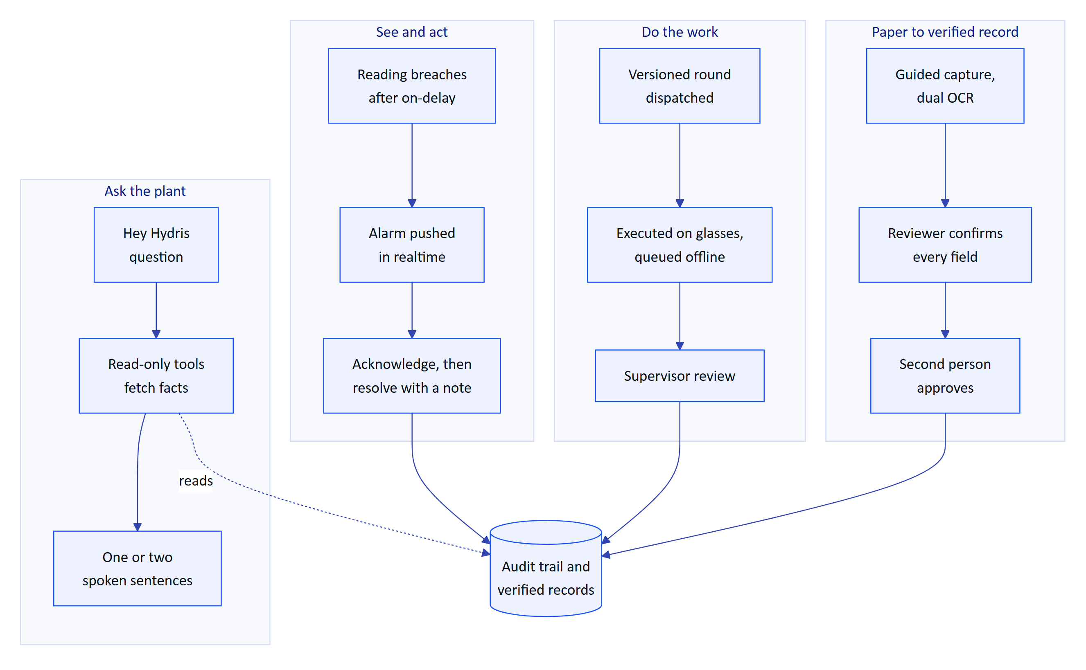
Figure 5. The four core loops and the record each one produces
Table 8. The core loops, what makes them trustworthy, and status
Loop | What makes it trustworthy | Status
See and act | Deadband and on-delay stop flapping; an alarm cannot be resolved without a note, so acknowledged is never mistaken for fixed | Built; Android Resolve fix in Hardening (FR-094)
Do the work | Templates are versioned; responses queue on the device and replay exactly once | Built on glasses; Android inspections Planned (FR-044)
Paper to verified record | The original extracted value is kept beside every correction; approval must come from a different person | Built
Ask the plant | Answers use only tool results from the same conversation and state the age of each reading; unknown questions get "can't answer" | Built (English)

4.4 Release scope by product
The MVP is complete in code. The pilot adds the hardening and hardware validation needed to run at a real plant; GA and later phases broaden reach.
Table 9. Release scope by product, pilot versus later
Product | Pilot (Q1 2027) | Later (GA Q2 2027 and Advanced)
Website and demo | As built | Content updates only
Operator console | Compliance summary (FR-120), alarm escalation (FR-037), email transport (FR-086) | SSO (FR-011), recurring schedules (FR-047)
Glasses app | As built, on the web runtime and phone layout | Native glasses display rendering
Hydris Field Android | Resolve fix (FR-094), inspections (FR-044), FR-099 fixes | FCM push (FR-034), offline outbox (FR-098), Play or MDM distribution
Ray-Ban Meta integration | Hardware validation of camera, capture button, speech, registration (FR-055 to FR-057, FR-074) in Developer Mode | Store or Developer Center distribution
Audit scanning | Page images moved to object storage | E-signatures (FR-068), LIMS
Voice assistant | English, rules or model engine per tenant consent | Hindi, Tamil, Marathi, Gujarati (FR-073)
Platform API and data | CI (NFR-010), job cadence (NFR-008), observability (NFR-034) | India-region production (NFR-017), pen test (NFR-018), MQTT and OPC UA (FR-027)

DECISION
The pilot runs on the native Android app, not the WebView bridge. The native app keeps device tokens in the Android Keystore, uses ML Kit for on-device OCR and talks to DAT directly. Every glasses feature also works on the phone, so the pilot does not depend on Meta's distribution timeline.

5 Operator console
The operator console is the web application at /console where supervisors, managers, auditors and administrators run the plant record. Field operators produce data with the glasses and the Android app; the console is where that data is dispatched, triaged, reviewed, approved and reported. It is one Next.js surface (apps/web/src/console) over the same API that serves every other client, so a value acknowledged on the glasses is the same record a manager sees on the overview a second later.
Table 10. Console sub-products
Sub-product | Route | Job it does | Status
Overview dashboard | /console | Is anything wrong right now, and where | Built
Plant model and map | /console/map, sites, assets | Describe the plant once and place it on a map | Built
Telemetry | Sensor monitoring | Honest live values with source and freshness | Built (HTTPS)
Alarms | Alarms and events | Turn readings into attributed work | Built, escalation Planned
Inspections and maintenance | Inspections, maintenance | Design, dispatch and review rounds and tasks | Built, schedules Planned
Documents and SOPs | /console/documents | Approved procedures at the asset | Built
Glasses fleet and UI profiles | Devices, /console/glasses-profiles | Pair, revoke and configure glasses | Built
Audit review and approval | /console/audit-docs | Turn scanned paper into approved evidence | Built, e-signature Planned
Reports | /console/reports | Numbers managers and auditors can defend | Built, compliance Planned
Administration and roles | Members, settings, audit log | Who can do what, with no escalation | Built, email and SSO Planned

5.1 Overview
Water and wastewater plants still run on paper log sheets, phone calls and spreadsheets. The supervisor cannot see which rounds are late, the manager cannot prove to a regulator who saw an alarm and when, and the auditor receives evidence that cannot be traced to a person. The console replaces that patchwork with one tenant-isolated, site-scoped workspace where every state change is attributed, timestamped and written to an append-only audit trail. Navigation (Shell.tsx) hides any destination the current role lacks, and the API enforces the same check from one fixed role matrix (packages/domain/src/roles.ts, six roles, 38 permissions).

5.2 Users and user stories
Table 11. Console user stories
ID | Story | Priority
US-C1 | As a shift supervisor I want open alarms ranked by severity so that I triage the worst first | P0
US-C2 | As a shift supervisor I want to dispatch a route to an operator and review the result so that rounds are traceable | P0
US-C3 | As a shift supervisor I want to approve glasses pairing from any phone so that a new pair is live in minutes | P0
US-C4 | As a plant manager I want threshold rules with deadband and on-delay so that operators are not flooded by noise | P0
US-C5 | As a plant manager I want to approve verified audit documents so that paper logs become evidence | P0
US-C6 | As a plant manager I want alarm and inspection reports in CSV so that I can defend KPIs | P1
US-C7 | As a compliance auditor I want an append-only trail of who did what so that evidence is attributable | P0
US-C8 | As an organization admin I want to decide what each role sees on the glasses so that screens fit the job | P1
US-C9 | As an organization admin I want to invite members with a role no higher than mine so that privileges never escalate | P0

5.3 Scope
Table 12. Console scope
In scope | Out of scope
Overview, plant model and map, telemetry with freshness and corrections | User-configurable widgets, cross-site benchmarking
Alarm rules and five-state lifecycle | Any write path to plant equipment (Hydris is read-only towards the plant)
Inspection templates, routes, dispatch, review; maintenance tasks | Digital twins, P&ID import
Document library with approval; grounded SOP retrieval | Bulk import of the asset register (gap)
Glasses fleet, pairing approval, UI profiles | Fleet health signals such as battery (next step)
Audit document review and four-eyes approval | Capture and OCR (glasses and Android sections)
Reports in JSON and CSV; admin, roles, audit log | Pricing, billing

5.4 Overview dashboard
The overview is the first screen after sign-in: KPI tiles, open alarms by severity, asset health, live measurements with freshness and recent activity. It is served by GET /overview, the same endpoint that feeds the Android home screen, so the console and the phone never disagree. Stale values are excluded from health roll-ups (packages/domain/src/freshness.ts) and synthetic values carry a visible label. A command palette (CommandPalette.tsx) gives keyboard access to every destination and global search. Next step: a per-user default site and a compliance tile once FR-120 lands.

5.5 Plant model and map
Everything hangs off the plant model: organization, site, facility, process area, asset and sensor. The site is the permission boundary, so a site-scoped supervisor sees nothing from other sites. Archiving an asset removes it from glasses screens and assistant answers while keeping its history. The plant map (/console/map) places assets on the site layout and overlays route stops and open alarms; the hierarchy navigator and asset schematic give the same model as a tree and per asset. Gateways authenticate with hgw_ API keys. Gaps: no bulk import of the asset register, and the map is drawn per site rather than imported from drawings.

5.6 Telemetry
The core promise is honesty: a missing reading is shown as "No data", never as zero, and every value carries its source (gateway, manual, lab or synthetic) and time. Gateways post up to 500 readings per call; readings are keyed on sensor and timestamp so a replayed batch never duplicates. Freshness is live up to twice the expected interval, delayed up to five times, then stale. A wrong value is never edited: a supervisor adds a correction or invalidates it, and the original stays visible with author and reason. MQTT, OPC UA and historian connectors are Planned.

5.7 Alarms
Alarms turn readings into attributed work. Acknowledging records that a person has seen the alarm; it never changes the process. Rules support HH, H, L, LL and stale conditions with deadband (no flapping around a limit) and on-delay (short spikes ignored). There is no path from active straight to resolved, and the API rejects a resolve without a note. Every transition writes a history row and an audit event, and pushes in realtime to the console, glasses and Android.
RISK
Stale rules run every 30 s on a long-running server but only once a day on the current Vercel cron (FR-035, Partial), and unacknowledged alarms do not escalate (FR-037, Planned). Both block an unsupervised pilot.

5.8 Inspections and maintenance
A template is built in the console (TemplateBuilder.tsx) from five step kinds: check, reading with expected range, choice with abnormal options, text and photo. Editing creates a new version, so dispatched inspections keep the version they started with. Routes order templates along a walk and are dispatched to an operator. The supervisor reviews a submitted inspection with abnormal steps highlighted and approves it or returns it with a reason; offline responses from the glasses replay idempotently, so the reviewer never sees duplicates. Maintenance tasks are corrective, preventive or follow-ups from an alarm or inspection, with priority, checklist and activity log, and move through open, assigned, in progress, on hold, completed or cancelled, with reopen. Every round is dispatched by hand today; recurring schedules are Planned.

5.9 Documents and SOPs
The library holds SOPs, manuals, datasheets, safety notices and troubleshooting guides, each with versions and a scope of site, asset or asset type. The lifecycle is draft, approved, archived, and only approved documents reach the glasses, the assistant and grounded retrieval. Alarm rules link a procedure shown with the alarm. The library page exposes grounded SOP retrieval (/assist), so a supervisor can check what an operator will be told before it happens. Uploading existing PDF manuals with text extraction is Planned.

5.10 Glasses fleet and UI profiles
Glasses are shared, often unattended devices, so the console makes them a managed fleet. A supervisor approves pairing to a site and an operator; the glasses never hold a user password, only a device credential the console can end. Devices move through pending, paired, assigned, connected, disconnected (not seen for 90 s), suspended and revoked. Access tokens last 15 minutes and refresh tokens rotate with reuse detection. A device can never exceed the device permission ceiling, whatever the operator's role.
A UI profile controls what the glasses show. Profiles are drafted, published and rolled back; assignment is by device, user, role or organization, and the most specific published assignment wins. Publishing pushes the change live without a restart.

5.11 Audit review and approval
Scanned paper logs become evidence only after one person has checked them and a second has approved them. The reviewer sees each extracted value beside its crop of the page, with the engines that read it and their agreement. Values where at least two engines agree with confidence 0.8 or more can be bulk-confirmed; everything else is confirmed, corrected or flagged one by one, and the original reading is always kept. Verify is blocked while any item is pending or flagged. Approval needs auditdoc.approve and must come from someone other than the verifier (demo tenants allow recorded self-approval). The approved PDF carries the verification trail, the searchable original and a reconstructed page.

5.12 Reports
Reports (insights.ts) cover inspections, alarms, maintenance, devices and operators, in JSON for the page and CSV for export. The alarm report includes median minutes to acknowledge; the inspection report includes on-time rate and the share submitted via glasses. These fields feed most pilot KPIs. A compliance summary per discharge point, the report regulators actually ask for, is Planned.

5.13 Administration and roles
The rule is no escalation: nobody can grant a role above their own (assignableRoles). Invitations carry a 7-day token; members can belong to several organizations and switch; sessions can be listed and revoked; TOTP MFA is available. The audit log page filters the append-only trail by action and entity, and no API path updates or deletes an audit event. Platform admins create and suspend customer organizations at /console/platform. Invitation emails are queued in mail_outbox but not yet sent.
Table 13. Role access summary (roles.ts)
Capability | Admin | Manager | Supervisor | Engineer | Operator | Viewer
Acknowledge alarms | Yes | Yes | Yes | Yes | Yes | No
Resolve / close alarms | Yes / Yes | Yes / Yes | Yes / Yes | Yes / No | No | No
Manage alarm rules, plant model | Yes | Yes | No | No | No | No
Review inspections, manage maintenance | Yes | Yes | Yes | No | No | No
Pair glasses / manage profiles | Yes / Yes | Yes / Yes | Yes / No | Yes / No | Yes / No | No
Verify / approve audit documents | Yes / Yes | Yes / Yes | Yes / No | No | No | No
Audit log | Yes | Yes | No | No | No | No

DECISION
The auditor persona maps to viewer, which holds report.read but not audit.read. Open decision: grant audit.read to viewer or add a dedicated auditor role.

5.14 Functional requirements
Priorities map the source PRD as Must to P0, Should to P1 and Could to P2.
Table 14. Console functional requirements by sub-product
ID | Requirement | Pri | Status
FR-089 | Overview: KPIs, open alarms, health, live measurements | P0 | Built
FR-085 | In-app notifications in realtime, mark as read | P0 | Built
FR-088 | Global search across assets, sensors, documents and work | P1 | Built
FR-020 | Plant hierarchy with map positions, archive and restore | P0 | Built
FR-021 | Sensors for 16 measurands with unit normalization | P0 | Built
FR-007 | Site-scoped permissions | P0 | Built
FR-022 | Gateway ingestion, 500 per call, idempotent | P0 | Built
FR-023 | Manual and lab entry with provenance | P0 | Built
FR-024 | Append-only corrections (correct or invalidate) | P0 | Built
FR-025 | History, raw readings, CSV export | P1 | Built
FR-026 | Freshness: live, delayed, stale, no data | P0 | Built
FR-029 | Synthetic data labelled, refused for customers | P0 | Built
FR-027 | MQTT and OPC UA adapters | P1 | Planned
FR-028 | Read-only SCADA and historian connectors | P2 | Planned
FR-030 | Threshold rules with deadband and on-delay | P0 | Built
FR-031 | Five-state lifecycle, no resolve from active, note required | P0 | Built
FR-032 | Assignment, notes, history, recommended action | P0 | Built
FR-033 | Realtime push to console, glasses, Android | P0 | Built
FR-035 | Stale-data alarms on a schedule | P0 | Partial
FR-037 | Escalation when unacknowledged | P1 | Planned
FR-038 | Shelving with reason and expiry | P2 | Planned
FR-040 | Versioned templates, five step kinds, routes, dispatch | P0 | Built
FR-042 | Submit, review, approve or return | P0 | Built
FR-043 | Maintenance tasks, checklists, follow-ups | P0 | Built
FR-047 | Recurring schedules | P1 | Planned
FR-110 | Document library: draft, approved, archived; versions; scope | P0 | Built
FR-111 | Only approved documents reach glasses and assistant | P0 | Built
FR-112 | Alarm rule links a procedure shown with the alarm | P0 | Built
FR-070 | Grounded SOP retrieval with safety notice | P0 | Built
FR-114 | Upload PDF manuals with text extraction | P2 | Planned
FR-050 | Pairing code, QR, 5 min TTL, 3 s polling, approval | P0 | Built
FR-051 | Device tokens, rotation, reuse detection | P0 | Built
FR-052 | Suspend, reactivate, revoke, reassign | P0 | Built
FR-053 | Device permission ceiling | P0 | Built
FR-054 | UI profiles: draft, publish, rollback, precedence, live push | P1 | Built
FR-064 | Confirm, correct, flag, reset; verify gate | P0 | Built
FR-069 | Bulk-confirm agreed multi-engine values | P1 | Built
FR-065 | Independent approval (four eyes) | P0 | Built
FR-066 | PDF with trail, searchable original, reconstruction | P0 | Built
FR-068 | Electronic signature with re-authentication | P1 | Planned
FR-081 | Reports for five areas in JSON and CSV | P0 | Built
FR-120 | Compliance summary per discharge point | P1 | Planned
FR-121 | Scheduled report delivery by email | P2 | Planned
FR-004 | Invitations, 7-day token, no escalation | P0 | Built
FR-012 | Fixed role matrix | P0 | Built
FR-082 | Append-only audit trail | P0 | Built
FR-087 | Audit log page with filters | P0 | Built
FR-010 | Platform organization create and suspend | P0 | Built
FR-005 | Password reset email | P0 | Partial
FR-086 | Email delivery (SMTP, SES or Resend) | P0 | Planned
FR-011 | SSO with SAML 2.0 and OIDC | P1 | Planned

5.15 Key flows
A new reading is normalized, stored idempotently and evaluated against rules before events reach every client.
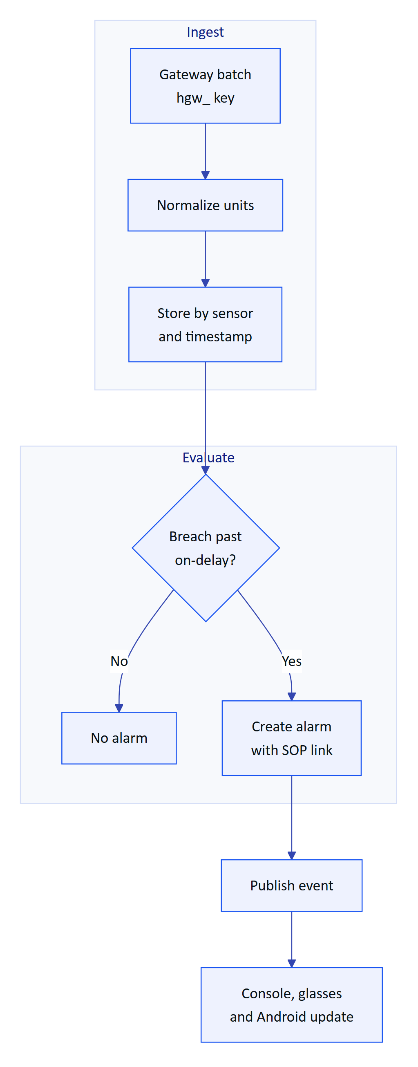
Figure 6. Telemetry to alarm (telemetry.ts, alarms.ts, realtime.ts)
An alarm must be seen before it can be resolved, and resolution needs a note.
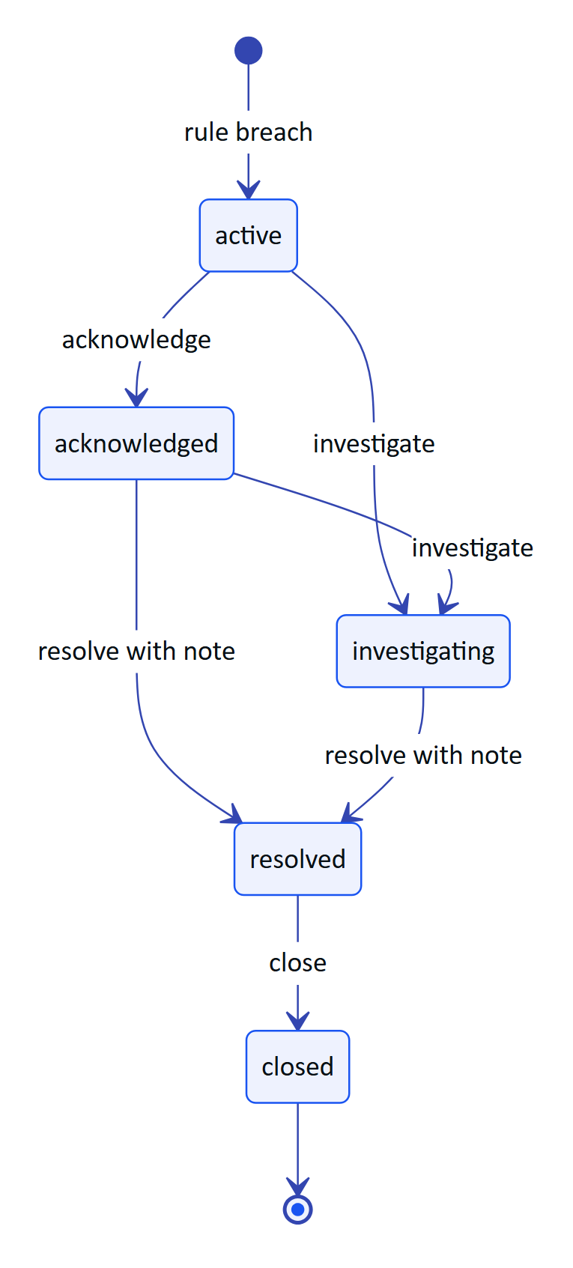
Figure 7. Alarm lifecycle (packages/domain/src/alarms.ts)
An inspection is dispatched, executed in the field and approved or returned by a supervisor.
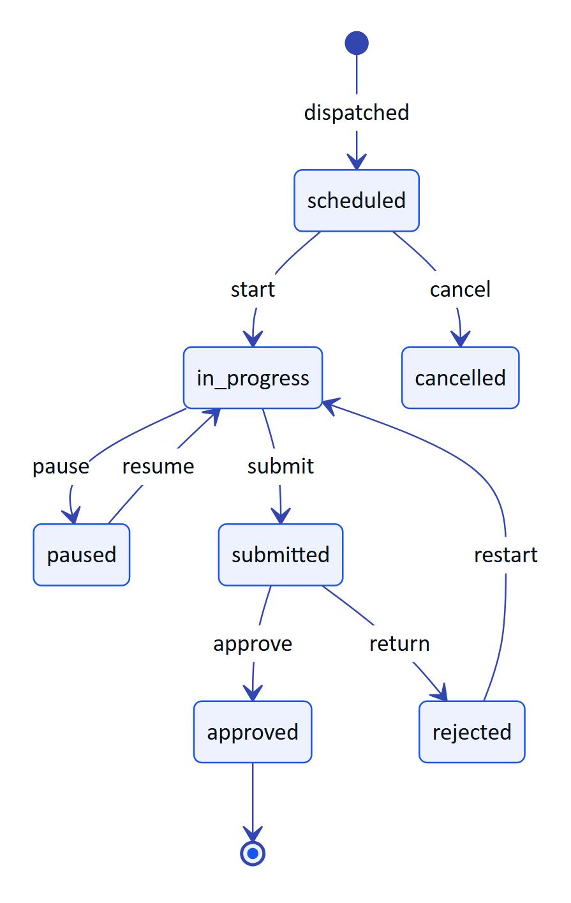
Figure 8. Inspection lifecycle (workflows.ts)
The glasses never type a password; a signed-in supervisor approves the code and the glasses claim their own credential.
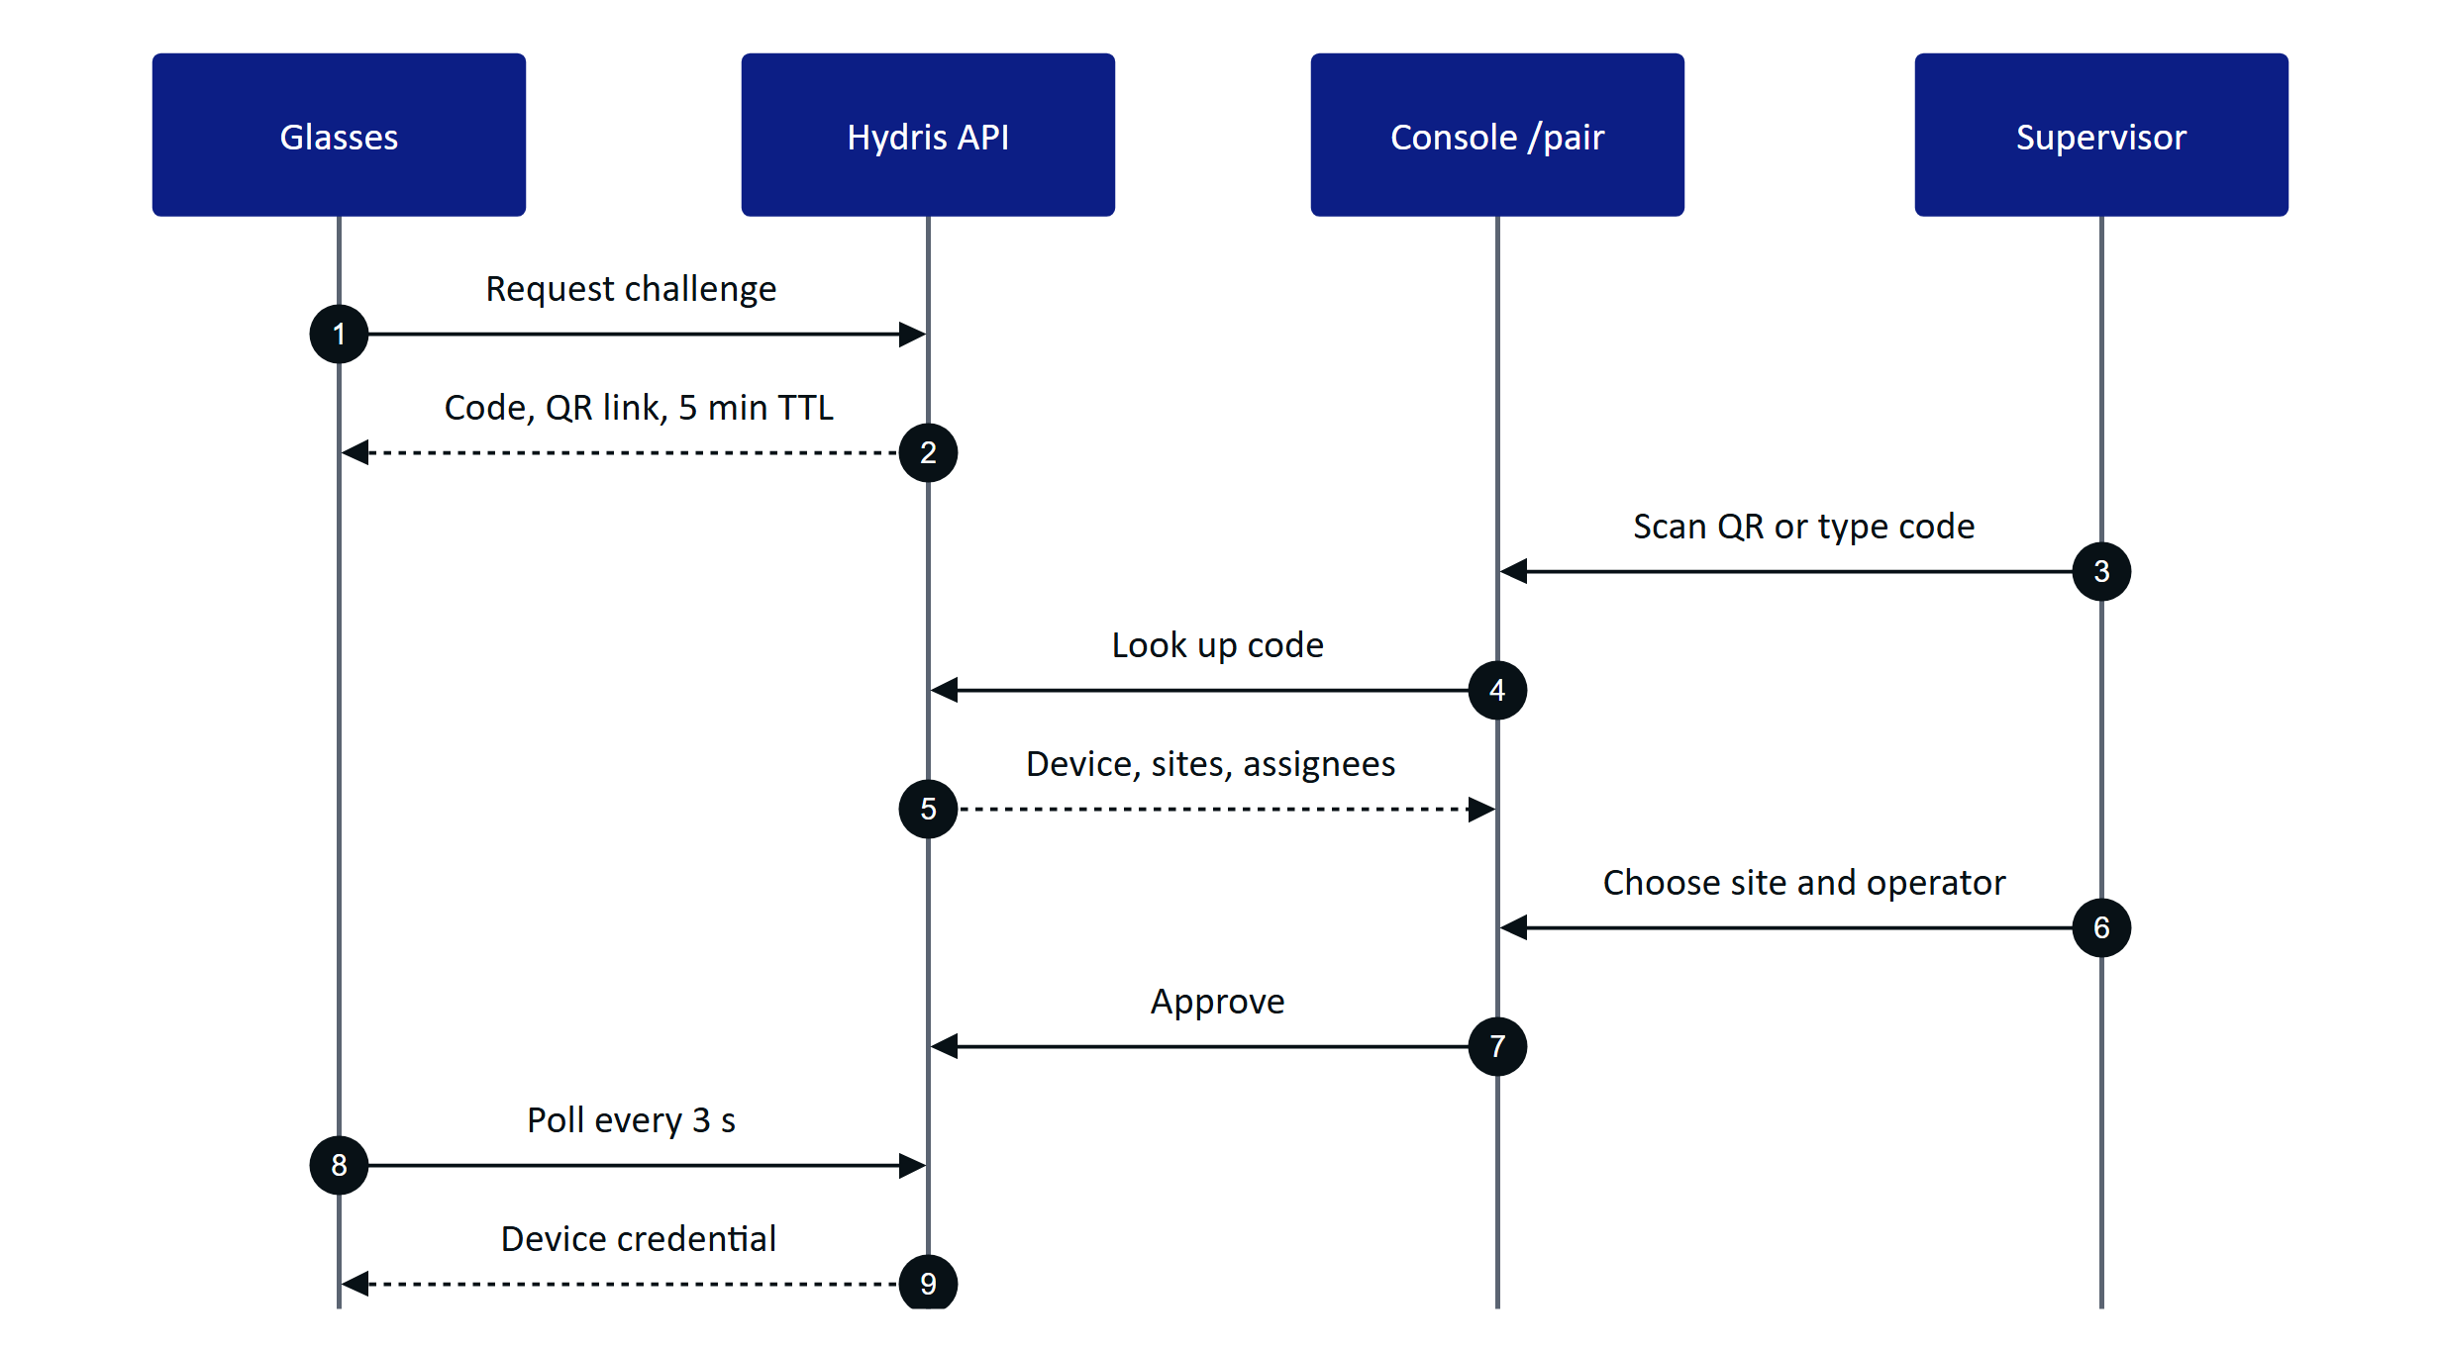
Figure 9. Console pairing approval (devices.ts)

5.16 Acceptance criteria
- Given an active alarm, when a user tries to resolve it directly, then the API rejects the transition; and given an acknowledged alarm, when resolve is sent without a note, then it is rejected (FR-031).
- Given a gateway batch already stored, when the same batch is replayed, then no duplicate readings are created (FR-022).
- Given a sensor with no reading, when the overview loads, then it shows "No data" and never zero (FR-026).
- Given a submitted inspection, when the supervisor returns it with a reason, then the operator can restart it and history shows both submissions (FR-042).
- Given a verified audit document, when the verifier tries to approve it in a customer tenant, then approval is refused (FR-065).
- Given a revoked device, when it makes its next request, then it is refused and its event stream closes within 30 s (FR-052).

5.17 Success metrics
All values are pilot targets, not measured results.
Table 15. Console metrics (pilot targets)
Metric | Source | Target
Median time to acknowledge, critical and high | Alarm report | Under 5 minutes
On-time round completion | Inspection report onTimeRate | 95 % or more
Share of rounds submitted via glasses | Inspection report viaGlasses | 50 % or more
Audit document capture to approval | Audit documents | Under 24 hours
Reviewer edits per reviewed field | Audit documents | Under 5 %
Device revocation to stream end | Event stream | 30 s or less
Realtime alarm delivery | NFR-002 | 2 s (not yet measured)
Cross-tenant incidents | Security review | 0

5.18 Dependencies and open issues
- Depends on the platform API, Postgres row-level security (FR-008) and the realtime event stream (FR-080).
- Blocks an unsupervised pilot: email delivery (FR-086), escalation (FR-037) and a reliable stale schedule (FR-035).
- Open: auditor role decision; compliance summary (FR-120); SSO (FR-011); electronic signature (FR-068); NFR-001 and NFR-002 not yet load-tested.

6 Website and demo

6.1 Overview
Industrial buyers rarely touch a product before a sales cycle starts, and smart-glasses software is hard to picture without hardware. The website explains Hydris and lets a prospect try it in minutes: drive the real glasses viewport in the browser, then sign in to the console or the Android app with just a name. Everything runs on synthetic data labelled as such. The goal is a self-serve path from curiosity to a working demo account with no sales contact.

6.2 Users and user stories
Table 16. Website and demo user stories
ID | Story | Priority
US-W1 | As a prospect I want to drive the glasses UI in my browser so that I understand the product without hardware | P0
US-W2 | As a prospect I want to sign in with only a name so that I can try the console immediately | P0
US-W3 | As a salesperson I want my named account to survive between sessions so that demos are repeatable | P0
US-W4 | As a trainer I want deterministic scenarios so that every class sees the same events | P1
US-W5 | As a prospect I want to request a guided demo so that I can talk to the team | P1

6.3 Scope
Table 17. Website and demo scope
In scope | Out of scope
Seven public pages plus privacy, phone and desktop, light and dark | Self-serve sign-up for customer tenants
Contact and demo-request form | Pricing pages, payments
Client-side glasses demo with ten scenarios; browser simulator and pairing | Real plant data of any kind
One-click named demo accounts on console and Android | Guest data beyond the shared store's 30-day TTL

6.4 Functional requirements
Table 18. Website and demo requirements
ID | Requirement | Pri | Status
FR-100 | Marketing website, seven pages and privacy page | P0 | Built
FR-101 | Contact form, 5 per 10 minutes per client | P0 | Built
FR-102 | Client-side glasses demo plus browser simulator | P0 | Built
FR-103 | Named guests with personal copies of open work | P0 | Built
FR-083 | Zero-configuration demo tenant, cross-instance pairing | P0 | Built
FR-084 | Ten deterministic scenarios, refused outside demo tenants | P0 | Built
FR-091 | Demo sign-in with a name in the Android app | P0 | Built
FR-029 | Synthetic data labelled, refused for customer tenants | P0 | Built

6.5 Key flows
A guest id is derived from the normalized name, so the same name always returns to the same account, rebuilt on any serverless instance from the shared store.
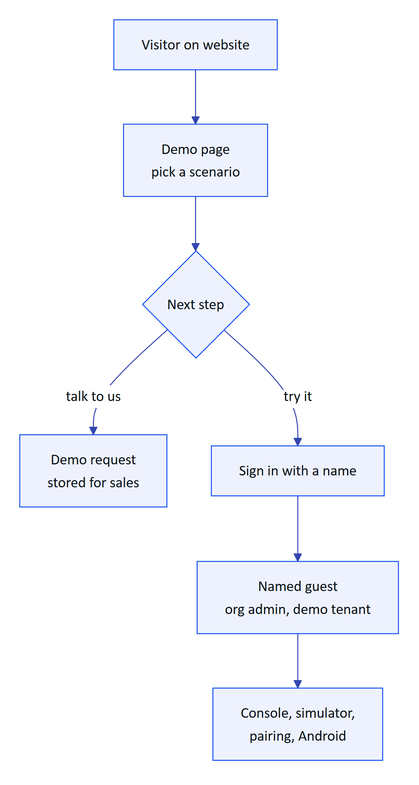
Figure 10. From visitor to named demo account

6.6 Acceptance criteria
- Given a deployment with no environment variables, when a visitor opens /demo and signs in, then the demo works end to end (FR-083).
- Given a guest named "Asha", when she returns later with the same name, then she reaches the same account and work (FR-103).
- Given two guests acting at once, when one completes an inspection, then the other's copies are unchanged (FR-103).
- Given a customer tenant, when a simulation scenario is started, then it is refused (FR-084).
WARNING
Demo mode relaxes security on purpose (12-hour access tokens, public signing secrets, audit self-approval). Production sets DEMO_MODE=false and SIMULATOR_ENABLED=false.

6.7 Success metrics
Table 19. Website and demo metrics (targets)
Metric | Target
Landing to signed-in demo account | Minutes, no sales contact
Demo on zero-configuration deployment | Works with no environment variables
Guest isolation failures | Zero
Demo requests converted to guided demos | Target to be set at pilot

6.8 Dependencies and open issues
- Inquiries are stored but no notification email is sent until email delivery (FR-086) lands.
- The Vercel Runtime Cache store is per region and best effort; Postgres is preferred where available.
- The demo mimics glasses input with on-screen buttons; a native display-glasses adapter is Planned.

7 Glasses app

7.1 Overview
Field operators walk rounds with gloves on, a radio in one hand and a log sheet in the other. They need the next inspection, the live reading at the asset in front of them, the nearby alarm and the right procedure without unlocking a phone or walking back to the control room. The glasses app is one web viewport (apps/web/src/glasses, served at /glasses) that puts this work at eye level. It records only: Hydris never operates equipment, and acknowledging an alarm says so.
Its principles are enforced in hud.tsx: one primary action per screen and six directional keys or voice for everything (NFR-021); body text of 20 px or more with light strokes on black for additive displays (NFR-020); cached data labelled with its age, never as live (NFR-026); and what a device shows decided in the console, not on the device (FR-054).

7.2 Users and user stories
Table 20. Glasses app user stories
ID | Story | Priority
US-G1 | As a field operator I want to record round steps hands-free so that I do not carry a log sheet | P0
US-G2 | As a field operator I want steps saved when the network drops so that no work is lost | P0
US-G3 | As a field operator I want to acknowledge a nearby alarm and open its SOP so that I act on the right procedure | P0
US-G4 | As a shift supervisor I want to pair glasses from my phone so that no password is typed on the device | P0
US-G5 | As an admin I want to change what a role sees without an app update so that screens fit the job | P1
US-G6 | As a prospect I want to run the full app in a simulator so that I can evaluate it without hardware | P1

7.3 Scope
Table 21. Glasses app scope
In scope (Built) | Out of scope or Planned
HUD layout, phone layout for the bridge, browser simulator | Rendering on a real glasses display (Planned)
Pairing by code and QR, device tokens, log out and unpair | Native Vuzix or RealWear hosts (Planned)
Home, alerts, inspections with offline queue, tasks, measurements, assets, map | Photo steps from the glasses camera (FR-045 Partial)
SOP library and reader with offline cache | Hardware gestures such as a temple touchpad (Planned)
Audit scan and Hey Hydris entry points | Multi-language voice (FR-073 Planned)

7.4 Runtimes
One React viewport runs in three places. useViewportLayout chooses phone mode inside the Android bridge (HydrisNative present), with ?mode=phone, or on a narrow portrait screen; otherwise HUD mode.
Table 22. HUD and phone runtimes
Aspect | HUD mode | Phone mode
Target | Display glasses, browser simulator | Bridge app on the phone paired with Ray-Ban Meta
Canvas | 600 x 600, scaled to window | 540-unit width, full height, safe areas
Navigation | Six keys, swipes, simulator pad | Bottom tabs (Home, Scan, Hey Hydris, Alerts) plus touch
Camera and voice | Simulated or device camera; browser speech | Glasses camera and microphone through the bridge

Twelve top-level screens (FR-059) sit under a Home menu whose order and visibility come from the UI profile; Home and Device can never be switched off. Navigation is a stack mirrored into browser history, so back never leaves the app.

7.5 Pairing
Pairing follows the shape of the OAuth device authorization grant (RFC 8628). The glasses show an 8-character code (no 0, O, 1, I, L or U) and a QR link valid for 300 s; a signed-in supervisor approves on /pair; the glasses poll every 3 s with a secret that is never displayed and receive a 15-minute access token and a 30-day rotating refresh token. On boot, a revoked, suspended or unassigned device shows that state plainly. Log out and unpair, behind a confirmation, ends the device sessions (FR-058).

7.6 Inspections with offline replay
The runner walks one step at a time through check, reading, choice and text steps; out-of-range readings, failed checks and abnormal choices are marked abnormal automatically. Every response is queued with a client operation ID before it is sent, so online and offline work share one path. The status bar shows "N queued"; on reconnect the queue replays once, idempotently, and the app reports the synced count or names the first conflict. Submitting needs a connection.

7.7 UI profiles
A profile is a versioned description of enabled screens and order, home widgets, allowed actions, a measurement filter and a text scale (0.9, 1, 1.15 or 1.3, NFR-019). Precedence is device, then user, then role, then organization. Publishing sends profile_changed, the glasses reload context without a restart, and the API enforces the same profile with 403 profile_forbidden. A blocked action shows "not permitted by your profile" rather than disappearing.

7.8 Functional requirements
Table 23. Glasses app requirements
ID | Requirement | Pri | Status
FR-059 | Heads-up app, 12 screens, six-key input, phone layout | P0 | Built
FR-050 | Pairing by code and QR, 300 s TTL, 3 s polling | P0 | Built
FR-051 | Device tokens: 15-minute access, 30-day rotating refresh | P0 | Built
FR-052 | Suspend, revoke, reassign; effective within 30 s | P0 | Built
FR-058 | Log out and unpair from the glasses menu | P0 | Built
FR-054 | UI profiles: draft, publish, rollback, live push | P1 | Built
FR-041 | Inspection execution with offline queue and replay | P0 | Built
FR-042 | Submit inspections; returned ones can restart | P0 | Built
FR-045 | Photo steps from the glasses camera | P1 | Partial
FR-112 | Alarm detail opens the linked SOP | P0 | Built
FR-113 | Opened SOPs cached for offline reading | P1 | Built
FR-060 | Guided A4 capture with auto-capture | P0 | Built
FR-071 | Hey Hydris wake phrase, short spoken answers | P0 | Built
NFR-025 | Inspection responses survive connectivity loss | P0 | Built
NFR-026 | Cached context shown as cached, never live | P1 | Built

7.9 Key flows
Every step is queued first, so a dropped network never loses work.
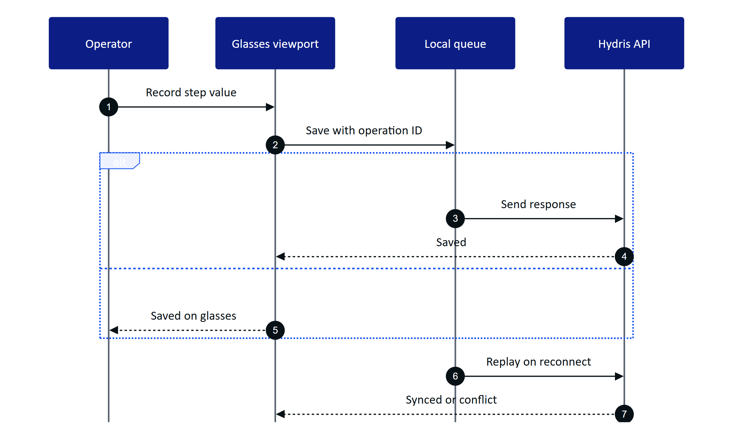
Figure 11. Recording a step online or offline (data.ts)
The viewport passes through explicit phases so device state is never hidden.
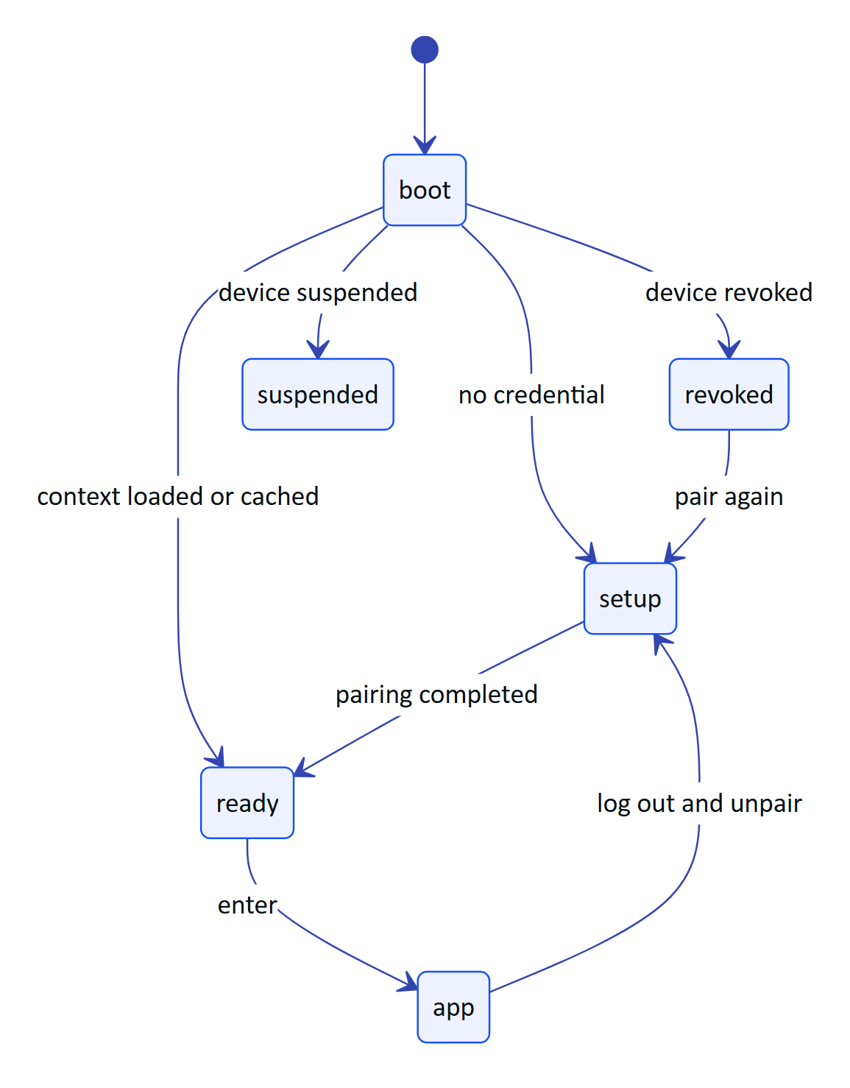
Figure 12. Viewport phases from boot to the app

7.10 Acceptance criteria
- Given an operator offline mid-round, when steps are recorded and the network returns, then every queued step syncs once with zero lost or duplicated (FR-041, NFR-025).
- Given a pairing code older than 300 s, when a supervisor tries to approve it, then approval is refused (FR-050).
- Given a profile that hides alarms, when the device calls the alarms API, then it receives 403 profile_forbidden (FR-054).
- Given a profile is published, when the glasses are on, then the menu changes without a reload (FR-054).
- Given an alarm detail, when the operator acknowledges, then the app confirms that equipment state is unchanged (FR-059).

7.11 Success metrics
Table 24. Glasses app metrics (targets, not measured)
Metric | Target
Home ready after wake | 2 s from cache, fresh data within 5 s (NFR-005)
Queued steps lost after reconnect | Zero (Playwright journey passes today)
Voice answer, end of speech to answer | 3 s rules engine, 8 s model (NFR-003)
Rounds completed on glasses in pilot | Set with the pilot customer

7.12 Dependencies and open issues
- Not yet run on a real glasses display; Vuzix M400, RealWear Navigator 520 and Meta Ray-Ban Display are Planned targets.
- The refresh token sits in local storage until hardware-backed storage exists.
- Depends on the console for pairing approval and profiles, and on the Ray-Ban Meta bridge for phone mode hardware.

8 Hydris Field Android app

8.1 Overview
Operators in effluent and sewage treatment plants walk rounds with a phone in their pocket and, increasingly, Ray-Ban Meta glasses on their face. The only app that talked to those glasses was Meta AI, a consumer assistant that knows nothing about the plant. Hydris Field (apps/android, Kotlin and Jetpack Compose) is the native companion for the working day: one Hydris account, the plant dashboard, alarms and work, audit scanning, the Hey Hydris assistant and the glasses link in one app. Meta AI stays installed as the connection broker, because Meta's Wearables Device Access Toolkit (DAT) requires it for pairing and permission prompts; after a one-time setup the operator opens only Hydris Field.

8.2 Users and user stories
Table 25. Android user stories
ID | User story | Priority
US-A1 | As a field operator I want to see what needs attention on my sites so that I act on the right thing first | P0
US-A2 | As a field operator I want to acknowledge and resolve an alarm where I stand so that the console reflects reality at once | P0
US-A3 | As a field operator I want to scan a paper log with my phone or glasses so that it reaches review without retyping | P0
US-A4 | As a maintenance engineer I want to tick checklist items in the field so that work orders stay current | P1
US-A5 | As a shift supervisor I want plant status, alarm trend and asset health in my pocket so that I can supervise while walking | P1
US-A6 | As a prospect I want a named demo account so that I can try the full product in minutes | P0

All users already hold a Hydris console account. The app adds no new account type and needs no mobile-specific server authentication.

8.3 Scope
Table 26. Android scope
In scope | Out of scope
Sign-in, demo mode, session restore | Administration of members, roles, sites, rules (console)
Home dashboard, five Work tabs, alarm and sensor detail | Reviewing and approving audit documents (console)
Audit scan from glasses, phone camera or import | Equipment control of any kind
Hey Hydris assistant and the Glasses tab | A heads-up display on Ray-Ban Meta (they have none)
Realtime alarm notifications while the app runs | iOS native app; replacing Meta AI

The app has five bottom tabs (Home, Work, Scan, Hydris, Glasses) and two detail screens (alarm, sensor). Each tab keeps its scroll position. Every glasses feature has a phone fallback: phone camera, phone microphone, phone speaker. Permissions are asked in context and the app keeps working when one is denied.

8.4 Functional requirements
Table 27. Android functional requirements
ID | Requirement | Priority | Status
FR-089 | Home and console overview from the same endpoint | P0 | Built
FR-090 | Console sign-in; session restored from a Keystore-encrypted refresh cookie | P0 | Built
FR-091 | Demo sign-in with a name of two or more characters | P0 | Built
FR-092 | Home: greeting, KPI tiles, 14-day trend, asset health, live measurements with freshness | P0 | Built
FR-093 | Work tabs (alarms, inspections, maintenance, sensors, audit docs) scoped to the user's sites | P0 | Built
FR-094 | Alarm detail with lifecycle actions; resolve requires a note | P0 | Partial
FR-095 | Sensor detail with 144-point history and typical range | P1 | Built
FR-096 | Audit scan from glasses, phone or import | P0 | Built (phone); glasses Partial
FR-097 | Realtime notifications for critical and high alarms while the app runs | P0 | Built
FR-098 | Offline outbox with idempotent replay | P1 | Planned (GA)
FR-099 | Complete MFA sign-in in the app | P1 | Planned (Pilot)
FR-044 | Run an inspection on the phone | P1 | Planned

FR-094 is Partial because buttons are not yet driven by the API's list of allowed actions: a button may be offered that the server then refuses. Server rules always win, and the screen reloads the true state with the server's message.

8.5 Key flows
Session restore keeps the operator signed in across app restarts without a password: the short-lived access token lives in memory, and the rotating refresh cookie is stored with AES-256-GCM under a non-exportable Android Keystore key (SecureStore.kt).
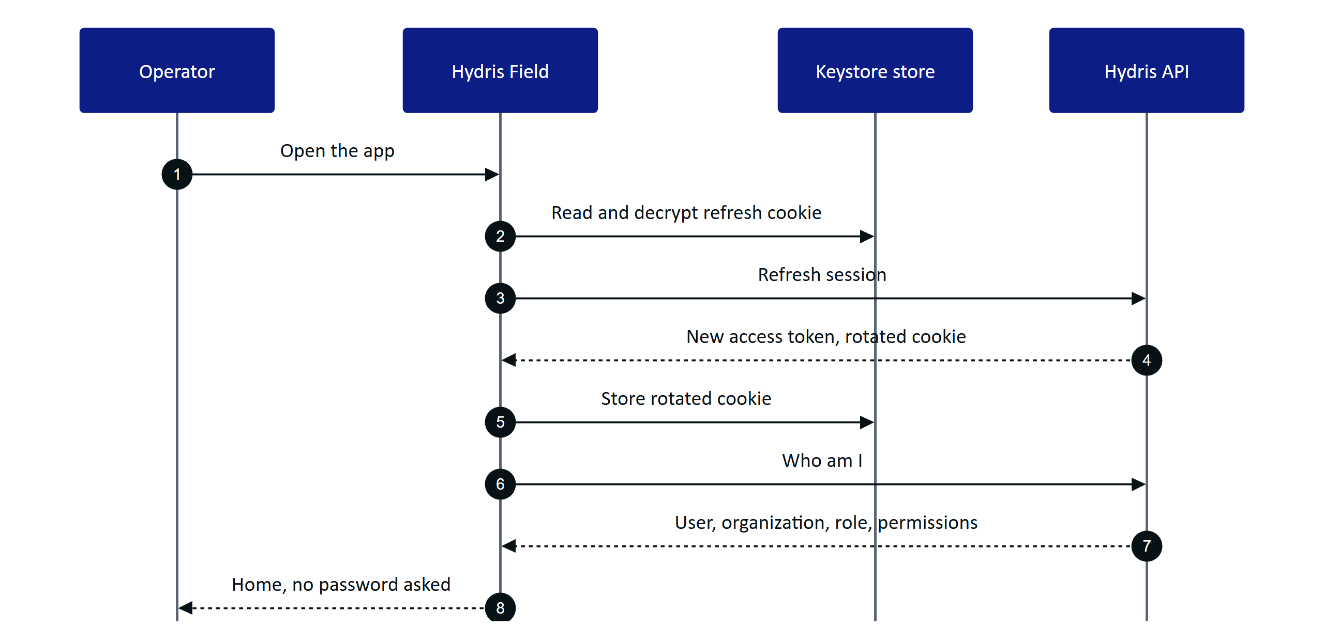
Figure 13. Session restore when the app starts
Alarms reach the phone over the server-sent event stream, which resumes with Last-Event-ID after a network drop; visible screens also poll (Home and alarms every 15 s, sensors every 10 s, audit documents every 20 s).
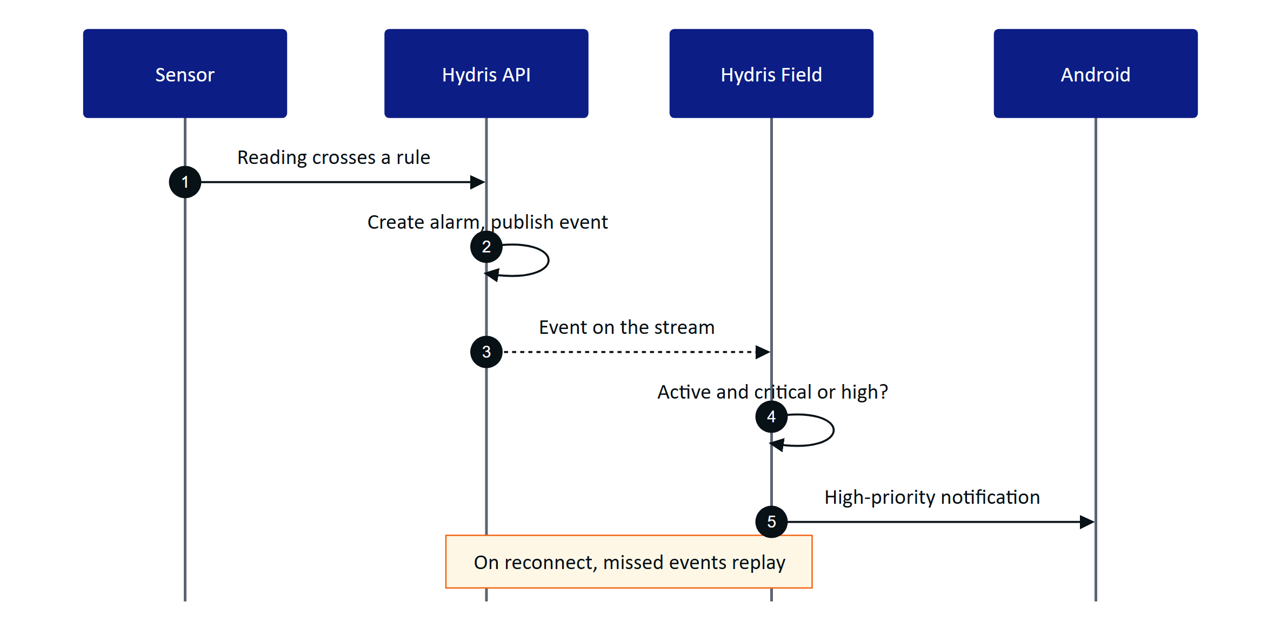
Figure 14. Realtime alarm notification from reading to phone
DECISION
Polling plus the event stream is deliberate for the pilot: every screen stays correct after a network drop without an offline cache. The cost is extra requests while a screen is visible. The Planned outbox and cache (FR-098) change this.

8.6 Acceptance criteria
- FR-090: Given a signed-in operator who kills the app, when they reopen it, then Home loads without a password; given a refused cookie, then Login shows "Session ended. Please sign in again."
- FR-090: Given several screens hit a 401 at once, when the app refreshes, then refreshes are serialized and only one rotated cookie is presented, so the server never sees reuse.
- FR-094: Given an acknowledged alarm, when the operator taps Resolve with an empty note, then the button stays disabled; with a note, then the alarm resolves and the console sees the update.
- FR-097: Given the app is running, when a critical alarm is created on the operator's site, then a high-priority Android notification appears.
- FR-092: Given a sensor with no readings, when Home renders, then it shows "No data", never zero, and synthetic values carry a "synthetic" label.
- FR-096: Given a printed lab sheet imported on the phone, when it is sent, then values are extracted and uploaded for review (verified manually on an emulated Pixel 7, API 35: 10 values including pH 7.3).

8.7 Success metrics
Table 28. Android success targets (targets, not measured results)
Measure | Target
Opening Scan to "Sent" for one A4 page | Under 60 s on a mid-range phone
Scans that auto-capture without "Capture now" | Above 70 %
Critical alarm to phone notification | Under 5 s while the app runs
Spoken answer after the question ends | Under 3 s on 4G
Crash-free sessions in pilot | Above 99.5 %

8.8 Dependencies and open issues
- Dependencies: the Hydris API and its event stream; Meta AI app and DAT for glasses; Android 12 or later (minSdk 31, NFR-029).
- Pilot gates: MFA in the app (FR-099), release signing (builds are signed with the debug key and may not leave the team), and the first glasses hardware run (Q4 2026).
- Notifications work only while the app runs; FCM push is Planned for GA (FR-034), and a notification opens the app rather than the alarm.
- Quality: no automated Android tests yet; unit and UI tests are required before pilot.
- Permissions: Bluetooth and notification prompts repeat on every start; asking once is Planned.
- Multi-site: glasses are registered to the first site; a site picker is needed before multi-site pilots.
RISK
Until release signing is in place no build may leave the team. MFA, release signing and the first hardware run gate the pilot handover.

9 Ray-Ban Meta integration

9.1 Overview
Ray-Ban Meta glasses are the lightest way to give an operator a camera, microphone and speakers at eye and ear level, but they have no display. Hydris uses them as hands-free sensors for the phone: the glasses camera frames and shoots paper logs, the microphone hears "Hey Hydris", the open-ear speakers play the answer, and the capture button takes the photo. The phone is the screen. Integration uses Meta's Wearables Device Access Toolkit (DAT 1.0.1) with core, camera, speech and inputs modules.
IMPORTANT
No Hydris build has yet run against physical Meta glasses. DAT calls compile and type-check, and the bridge page was tested with a stand-in. Hardware behaviour is Built, not hardware-verified, and requirements below are Partial until it is.

9.2 Users and user stories
Table 29. Ray-Ban Meta user stories
ID | Story | Priority
US-R1 | As a field operator I want to scan a paper log with the glasses camera so that my hands stay free | P0
US-R2 | As a field operator I want spoken answers on the glasses speakers so that I keep my eyes on the plant | P0
US-R3 | As a supervisor I want glasses registered as revocable devices so that I know who captured each scan | P0
US-R4 | As an operator without glasses I want phone fallbacks so that I lose nothing but convenience | P0
US-R5 | As a solutions engineer I want a clear setup path so that pilot kits work first time | P1

9.3 Scope
Table 30. Ray-Ban Meta scope
In scope | Out of scope
Ray-Ban Meta Gen 1 and Gen 2 (primary Gen 2) | Video recording or upload
Camera preview for guided capture, full-resolution photo | Replacing the Meta AI app
Glasses microphone, phone TTS on glasses speakers | Hydris UI on the glasses (no display)
Capture button short press | Long press and other gestures
Registering glasses as a Hydris device | Several glasses per phone

9.4 Meta AI app dependency and DAT lifecycle
Meta requires its Meta AI app to pair the glasses to the phone, update firmware, enable Developer Mode for unpublished apps, and approve each third-party app and each permission.
DECISION
The Meta AI app must stay installed and signed in. Hydris checks for package com.facebook.stella and, if missing, tells the operator to install it and pair there first. Hydris pairing is separate: it makes the glasses a managed device in the customer's organization.

DAT initializes only after Android grants Bluetooth permissions. Registration hands off to the Meta AI app and returns through a callback URL. Camera and microphone are DAT permissions approved in the Meta AI app, requested one at a time; a cancelled prompt counts as denied. One device session is shared by camera, speech and inputs: created when first needed, reused while started, and rebuilt after it stops. Preview frames (medium quality, 24 fps, at most every 100 ms to detection) are processed in memory for framing only and never stored; the photo is rotated upright and flattened to A4 (1654 x 2339). Images leave the phone only on "Send for verification".
Two routes share DAT and the backend: Hydris Field, the native Compose app and pilot runtime, and the Glasses bridge, a WebView hosting the /glasses viewport in phone mode for development comparison.

9.5 Registration
The Meta AI app pairs glasses to the phone; Hydris registration makes them a managed device assigned to a person and site, visible and revocable in the console, and credited for scans (FR-057). In the native app the signed-in user self-approves the device flow. The hardware ID is rbm- plus a SHA-256 digest of the DAT identifier, so the raw Meta ID never leaves the phone and re-registering reuses the same record. Glasses owned by another organization return device_owned_elsewhere.

9.6 Functional requirements
Table 31. Ray-Ban Meta requirements
ID | Requirement | Pri | Status
FR-055 | Glasses camera via DAT: preview and full-resolution photo | P0 | Partial (not on hardware)
FR-056 | Capture button takes the photo or starts a scan | P1 | Partial (not on hardware)
FR-057 | Android app registers glasses as a Hydris device | P0 | Partial (not on hardware)
FR-074 | Glasses microphone with phone fallback, answers on speakers | P0 | Partial (phone path Built)
FR-077 | "Hey Meta, start Hydris" opens the assistant | P2 | Partial (bridge only)
NFR-015 | Camera only on explicit intent, no continuous recording | P0 | Built
NFR-028 | 4-hour shift with up to 20 scans | P1 | Planned (measure)
NFR-029 | Android 12 or later | P0 | Built

9.7 Key flows
Registration with Meta happens once, in the Meta AI app, before any Hydris capability is used.
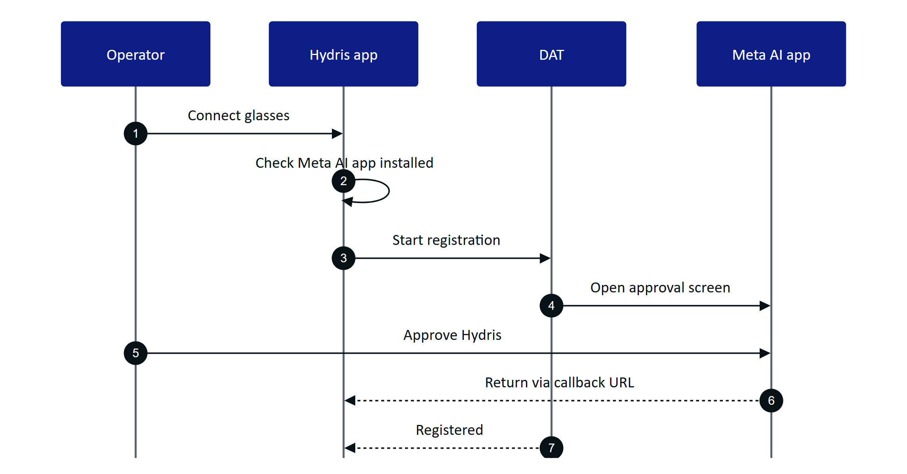
Figure 15. DAT registration hands off to the Meta AI app
One shared session serves camera, speech and inputs and is rebuilt cleanly after the glasses go away.
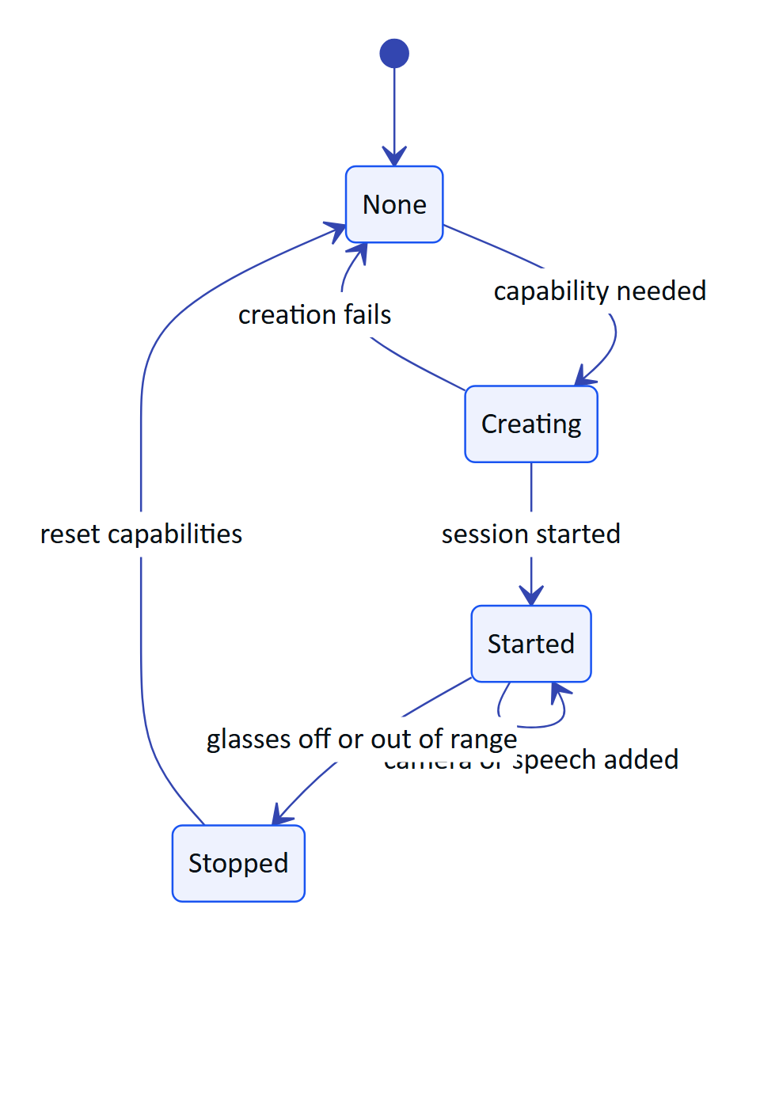
Figure 16. DAT device session lifecycle

9.8 Acceptance criteria
- Given the Meta AI app is missing, when the operator taps Connect glasses, then Hydris explains how to install and pair it (decision above).
- Given an active glasses preview, when the page is aligned and the capture button is pressed, then a full-resolution upright A4 image is returned (FR-055, FR-056).
- Given registered glasses, when an admin revokes them in the console, then later uploads from that device are refused (FR-057, GLS-T12).
- Given no glasses session, when the operator scans or asks a question, then the phone camera and microphone are used instead (FR-074).

9.9 Success metrics
Table 32. Hardware run targets (not measured)
Path | Target
First preview frame with an existing session | Under 3 s
Preview rate reaching detection | 8 to 10 fps
Photo returned after capture | Under 4 s
Speech restart gap after silence | Under 1 s
Battery | 4-hour shift with up to 20 scans

9.10 Dependencies and open issues
- Fifteen hardware acceptance tests (GLS-T01 to T15) are defined and none has run; first run on Gen 2 is the next step.
- The DAT camera stream is stopped only when the session ends; battery and capture-LED impact to be checked.
- Public DAT publishing is not open; pilots rely on Developer Mode and Developer Center release channels.
- Bridge hardening (navigation and permission restriction) is Planned before any distribution outside the team.
- The same glasses paired through both routes create two device records; pilots use one runtime per pair. A site picker for registration is Planned.

10 Audit document scanning

10.1 Overview
Treatment plants still run on paper: shift logbooks, round sheets, lab reports, permits and calibration certificates. These records are the evidence a regulator or auditor asks for, yet they are hard to search, easy to lose and slow to copy by hand, where a moved decimal point turns pH 7.1 into 71. Audit scanning turns a paper record into a verified, searchable PDF. The governing rule is dual verification: a machine cross-check of every value between independent readings, then a human review of every value and an independent approval by a second person.

10.2 Users and user stories
Table 33. Audit scanning user stories
ID | User story | Priority
US-S1 | As a field operator I want to capture a paper record with glasses or phone in under a minute so that evidence is digital at the point of work | P0
US-S2 | As a reviewer I want to confirm, correct or flag every value against the paper so that nothing wrong is verified | P0
US-S3 | As a plant manager I want to approve or reject a verified document so that a second person stands behind it | P0
US-S4 | As a compliance auditor I want a searchable PDF with the full verification trail so that I can rely on the record | P0
US-S5 | As a reviewer I want to bulk-confirm values where engines agree confidently so that review is fast | P1

10.3 Scope
Table 34. Audit scanning scope
In scope | Out of scope
Capture from glasses, phone camera, imported photo, console | Signing on the device: devices capture, people verify
Guided A4 framing, auto-capture, flattening | Electronic signature with re-authentication (Planned, FR-068)
Two on-device OCR passes; fields, tables, figures | Handwriting-specific recognition models
Plausibility checks and an optional vision engine | Bulk upload of existing PDF archives
Field review, verify, approve, PDF with trail | Writing values into plant records automatically

10.4 Functional requirements
Table 35. Audit scanning functional requirements
ID | Requirement | Priority | Status
FR-060 | Guided A4 capture with live detection, auto-capture, perspective correction | P0 | Built (web and Android)
FR-061 | Dual-pass on-device OCR (original and enhanced) | P0 | Built
FR-062 | Fields, tables, figures with plausibility checks | P0 | Built
FR-063 | Optional vision engine, each value cross-checked against OCR in its box | P1 | Built (needs a key)
FR-064 | Field review; original value kept; verify needs zero pending and flagged | P0 | Built
FR-065 | Independent approval by a different person (four eyes) | P0 | Built
FR-066 | PDF with trail, searchable original and reconstructed page | P0 | Built
FR-067 | Up to 6 pages, each at most 900 KB, JPEG or PNG | P0 | Built
FR-068 | Electronic signature with re-authentication | P1 | Planned (Advanced)
FR-069 | Bulk-confirm values where two engines agree with confidence 0.8 or more | P1 | Built
FR-096 | Scan from glasses, phone or import in the Android app | P0 | Built (phone); glasses Partial
FR-055 | Glasses camera capture through DAT | P0 | Partial (not run on hardware)

Guided capture speaks or shows one instruction at a time, in a fixed order (find page, move back, move closer, straighten, hold still), checking frames at most every 90 ms. It auto-captures after 900 ms of readiness and flattens the page to A4 at 200 dpi (1654 x 2339 pixels). Phone, glasses viewport and console share the same detection code and thresholds.

10.5 Key flows
The journey has three halves that never mix: the device captures and reads, the server structures and cross-checks, and people verify and approve.
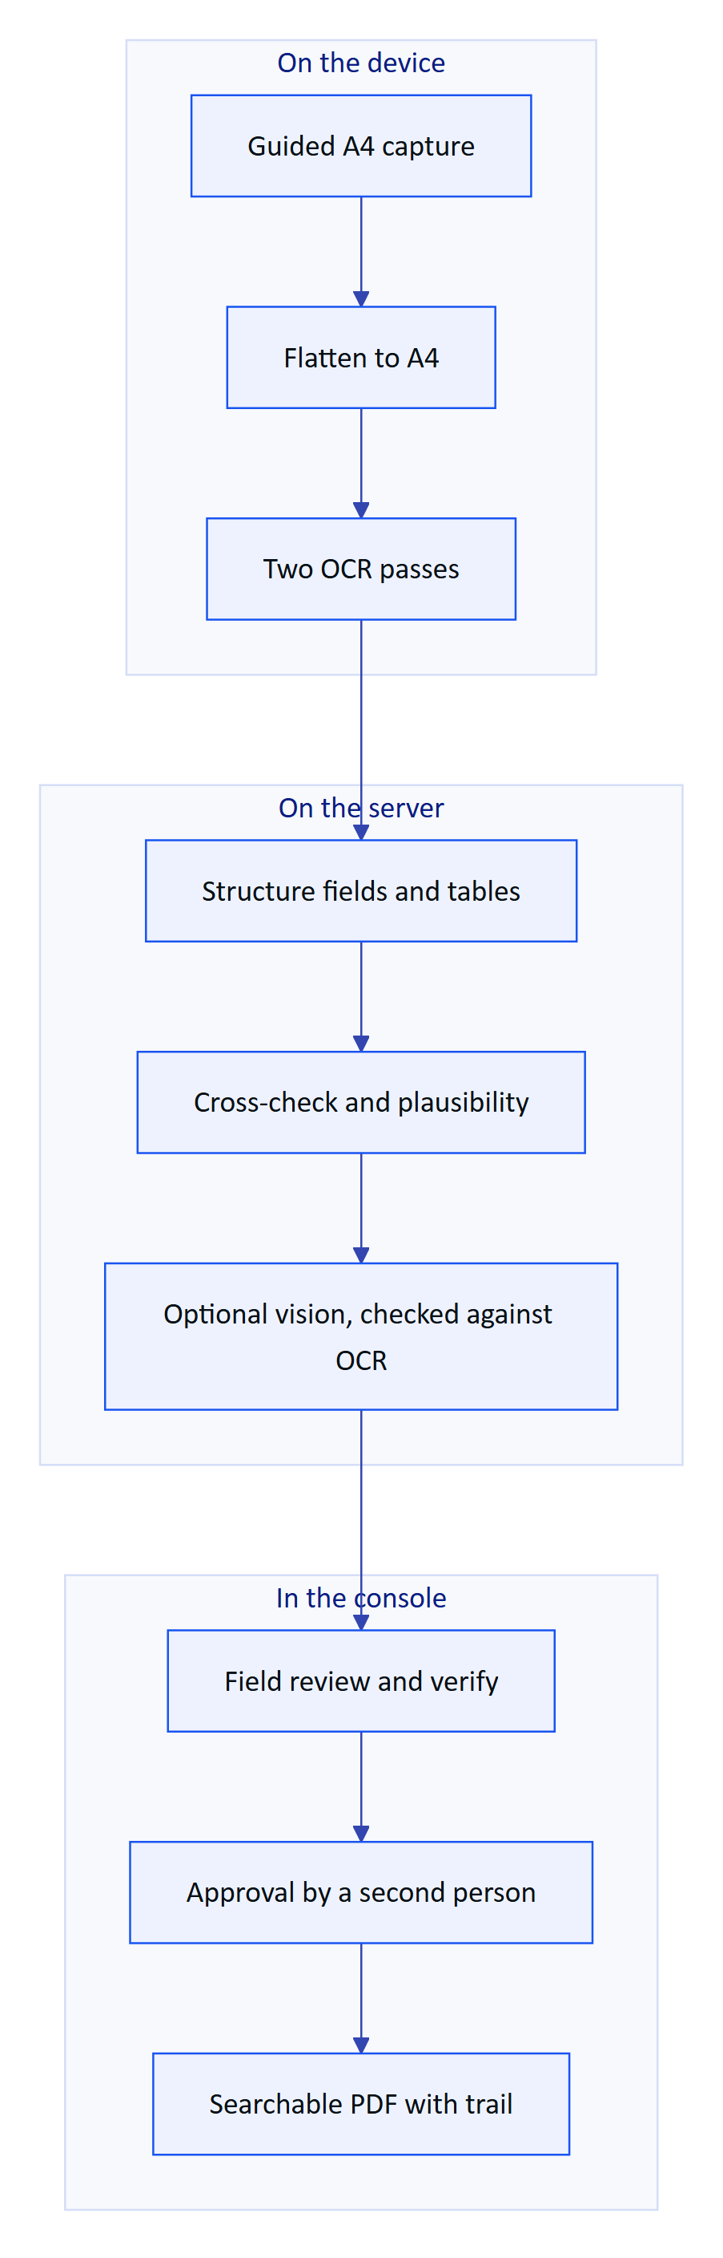
Figure 17. Paper record to verified PDF
Every review action is appended to the document's event history; any change after verification sends the document back to review, and approval must come from a different person.
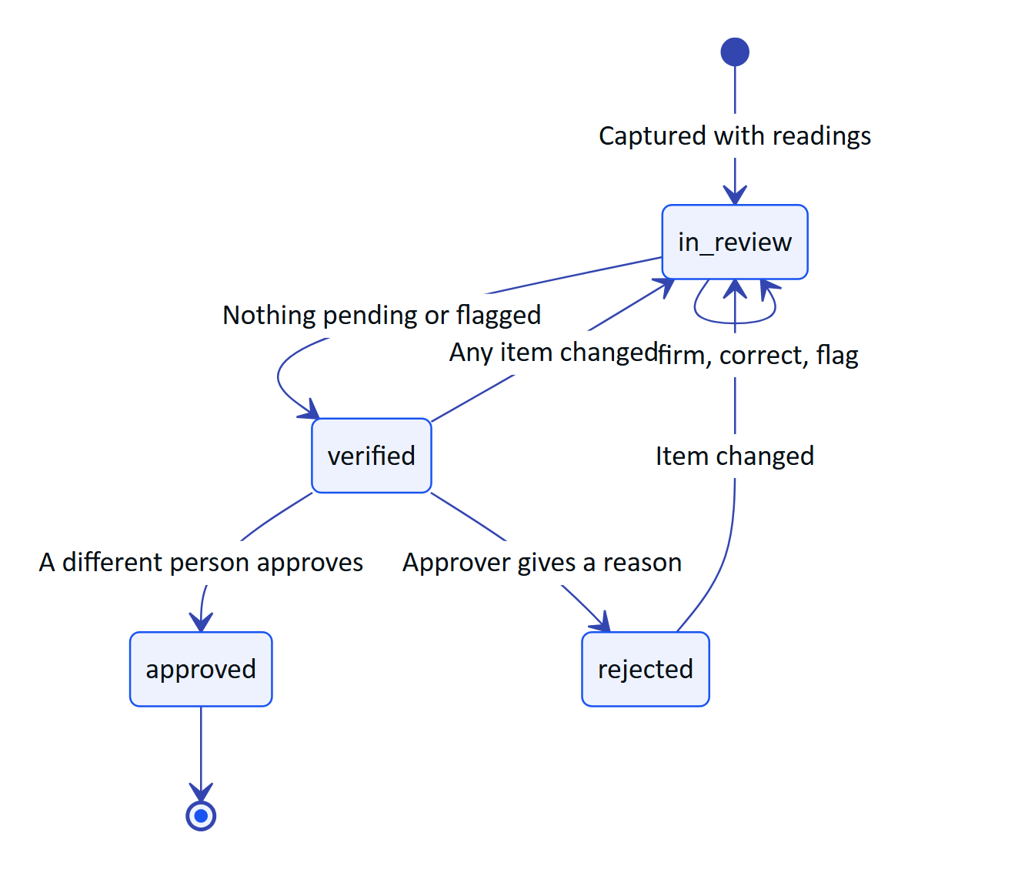
Figure 18. Audit document lifecycle and the four-eyes rule
Each value carries an agreement level between the passes (match, close, mismatch) and keeps its position on the page. Plausibility checks run even when both passes agree, because both can be wrong the same way.
DECISION
The primary quality metric is the silent error rate: a value marked as agreed and not flagged, but wrong. A system that is 85 % accurate and flags what it is unsure of is safer than one that is 95 % accurate and confidently wrong on the rest.

Table 36. Safeguards for the numbers that matter
Risk | Safeguard
Decimal point dropped or moved | "7.4" against "74" is always a mismatch; thousands separators are not
Both passes misread the same way | Range checks flag pH 71 and offer a matching labelled value as the fix
Letters and digits confused | O and 0 are folded inside numbers before comparison
Vision model invents a value | Checked against OCR text inside the value's box
Reviewer overwrites the machine value | The first extracted value is kept beside the correction

10.6 Acceptance criteria
- FR-060: Given an A4 sheet held aligned and still, when it is ready for 900 ms, then the device captures and flattens it without a button press.
- FR-062: Given both passes read pH as 71, when the server structures the page, then the value is flagged as implausible with a reason and a suggested fix.
- FR-063: Given a vision value with no supporting OCR text in its box, when results merge, then it is never marked as agreed.
- FR-064: Given a document with one pending or flagged item, when the reviewer tries to verify, then verify is blocked.
- FR-065: Given a verified document in a customer organization, when the verifier tries to approve it, then approval is refused; demo tenants allow self-approval and record it.
- NFR-031: Given two reviewers editing the same document, when the second saves with an old revision, then the write returns 409 stale instead of overwriting.

10.7 Success metrics
Table 37. Scanning quality targets (targets, not measured results)
Metric | Pilot target
Fields where the engines agree, typed forms | 90 % or more
Fields a reviewer corrects | Under 5 %
Silent error rate | Under 0.5 %
Decimal correctness | 99 %
Planted implausible values flagged | 100 %
Capture to review-ready per page | 15 s or less
Capture to approval, median | Under 24 hours

One manual demo (emulated Pixel 7, API 35) read a printed lab sheet correctly, including pH 7.3, with 10 values extracted. That is one sheet, not a benchmark.

10.8 Dependencies and open issues
- Benchmark not yet run. A 120-page ground-truth set is designed; until it runs, every accuracy number is a target.
- Glasses capture unproven on hardware. The DAT path works on Meta's mock device; the first Ray-Ban Meta run is scheduled for Q4 2026.
- Vision consent. A tenant must agree to vision processing and the deployment must record where inference runs; until then pilots run on OCR alone.
- Storage. Page images move to object storage during Hardening.
- Electronic signature (FR-068) is Planned for the Advanced phase.

11 Hey Hydris voice assistant

11.1 Overview
An operator at a clarifier with gloves on cannot scroll a dashboard. Hey Hydris lets them ask out loud ("what's the outlet pH?", "any open alarms?", "what are my tasks?") and hear a short answer on the glasses speakers or the phone, with the facts behind it on screen. Every answer comes from the caller's own plant data through read-only, tenant-scoped tools, never from general knowledge. The assistant is advisory only and cannot change anything.

11.2 Users and user stories
Table 38. Voice assistant user stories
ID | User story | Priority
US-V1 | As a field operator I want a reading, its age and alarm state by voice so that I keep my hands on the job | P0
US-V2 | As a maintenance engineer I want to hear my open work and an asset's procedure so that I act without the console | P0
US-V3 | As a supervisor I want to hear open alarms on my sites while walking so that I stay aware | P1
US-V4 | As any user I want to ask a follow-up without repeating context so that the conversation feels natural | P1

11.3 Scope
Table 39. Voice assistant scope
In scope | Out of scope
Wake phrase, spoken question, spoken answer | Operating equipment or changing records
Readings, alarms, my work, asset status, approved SOPs | Answers from outside the tenant's data
Follow-ups with history (up to 8 turns) | Indian languages (Planned, FR-073)
Glasses, phone and browser speech | "Hey Meta, start Hydris" as a supported path (experimental)

11.4 Functional requirements
Table 40. Voice assistant functional requirements
ID | Requirement | Priority | Status
FR-070 | Grounded SOP retrieval from approved documents with a safety notice | P0 | Built
FR-071 | Wake phrase and short spoken answers | P0 | Built
FR-072 | Answers only from tenant data through scoped tools; rules fallback never guesses | P0 | Built
FR-073 | Hindi, Tamil, Marathi, Gujarati | P1 | Planned (Advanced)
FR-074 | Glasses microphone with phone fallback; answers on glasses speakers | P0 | Partial (not run on hardware)
FR-075 | Facts with source; synthetic data labelled | P0 | Built
FR-076 | Follow-ups with history (up to 8 turns) | P1 | Built
FR-077 | "Hey Meta, start Hydris" opens the assistant | P2 | Partial (experimental)
FR-078 | No write tools | P0 | Built

11.5 Key flows
When an Anthropic credential is configured, Claude answers with up to five rounds of five read-only tools (readings, open alarms, my work, asset, procedures) that run in the caller's tenant and site scope; otherwise, or on any model error, a deterministic rules engine answers.
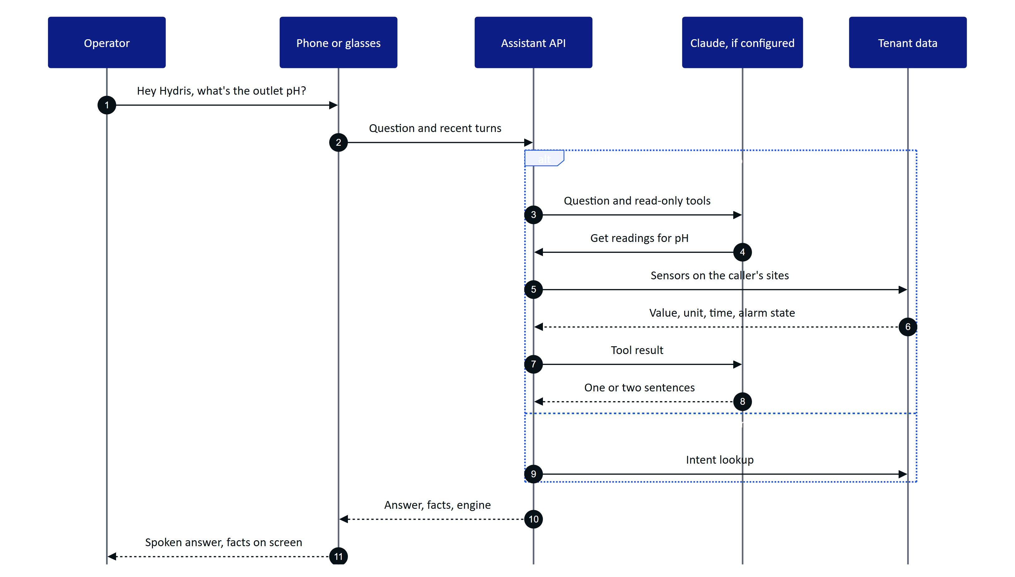
Figure 19. A spoken question answered from the caller's own data
The wake phrase is detected on the device with a pattern tolerant of how recognizers hear "Hydris". Transcripts are dropped while the assistant speaks, so it never answers itself; "stop", "cancel" or "thanks" ends the follow-up window.

11.6 Acceptance criteria
- FR-072: Given no model key, when the operator asks about the weather, then the answer is "I can't answer that from your plant data".
- FR-072: Given a site-scoped operator, when they ask about another site's sensor, then the answer contains nothing they could not see in the console.
- FR-075, NFR-036: Given a reading 12 minutes old, when it is answered, then the answer states its age; a stale reading adds "not current, check the sensor"; missing data is "no data", never zero.
- FR-078: Given any question, when the assistant runs, then only read tools are available and no record changes.
- FR-074: Given glasses linked but the glasses microphone denied, when the assistant listens, then it falls back to the phone microphone, then to typing.

11.7 Success metrics
Table 41. Voice targets (targets, not measured results)
Metric | Pilot target
Questions answered with facts, not "can't answer" | 85 % or more
Numbers in answers missing from facts | 0
Spoken answer after the question ends | Under 3 s (rules) and 8 s (model) on 4G, NFR-003

11.8 Dependencies and open issues
- Logging of engine and intent is Planned for the pilot; until then the targets cannot be measured.
- Glasses microphone on Ray-Ban Meta hardware is a first hardware run item for Q4 2026.
- False accepts of the wake phrase are tested against eight hours of plant conversation before the pattern is tightened.
- Follow-up window: the glasses viewport closes after 8 s of silence; Android waits for a stop phrase. Aligning on 8 s is Planned.
- Model consent: a tenant must agree to Claude processing; otherwise the rules engine runs alone.

12 Platform, data and integrations
Every Hydris surface (website, operator console, glasses HUD, Hydris Field Android app) talks to one platform: a modular API over one Postgres schema with row-level security. This section states what the platform must guarantee to every product: isolation, security, honest data, safe integration and AI that never acts without a person.

12.1 Architecture summary
Hydris is an npm workspaces monorepo. The API (apps/api, Fastify 5) is a modular monolith of fifteen route modules sharing core services (tenant context, event bus, audit, storage, crypto). It runs inside the Next.js web deployment through a catch-all route that calls app.inject (no network hop), or as its own container. A pure TypeScript domain package (packages/domain) holds state machines, permissions, freshness and voice parsing rules shared by server and web; the Android app mirrors them by hand.
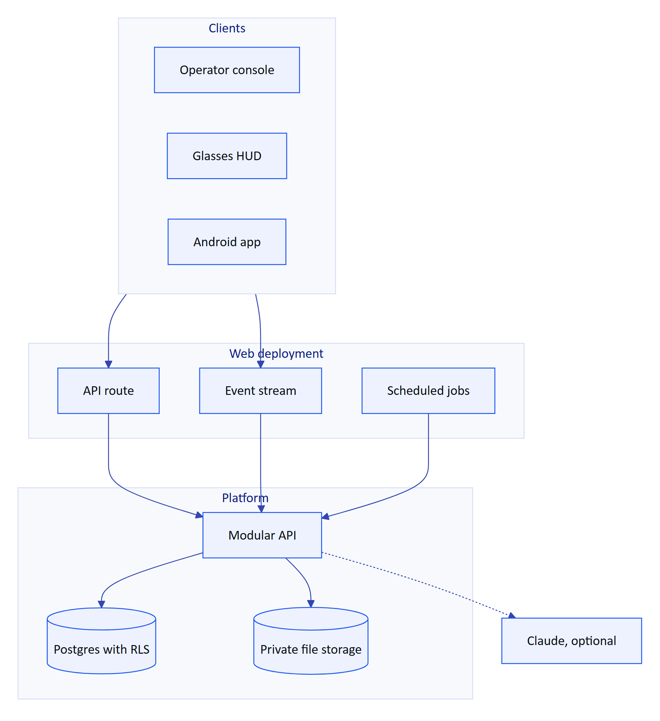
Figure 20. Platform containers: all clients share one API and one event stream
One validated configuration (apps/api/src/config.ts) selects Postgres or in-process PGlite, the realtime mode, cloud or disk storage, and an external API. The same code runs on Vercel, in Docker Compose at a plant, in a hybrid set-up and as the self-contained public demo.
DECISION
A modular monolith (ADR-002) with the API inside the web deployment (ADR-003) gives one deployable and in-process calls for the pilot. The trade-off is module discipline and a cold start that builds the app and migrates.

12.2 Tenancy and security requirements
Isolation is enforced by Postgres, not only by application code. Every tenant table has row-level security enabled and forced, with one policy comparing the row's organization to a per-transaction setting (SET LOCAL, so nothing leaks across pooled connections). Requests run as the non-privileged role hydris_app. On top sit RBAC (six roles, 38 permissions in packages/domain/src/roles.ts) and site scope; out-of-scope records return 404, not 403, so users cannot probe for other sites.
The principal is reloaded from the database on every request, so a revoked session or device stops at once. People sign in with argon2id-hashed passwords and optional TOTP MFA, receive a 15-minute access token and a 7-day rotating refresh token; reuse of a rotated token after a 30-second grace revokes the whole family. Devices never see a password: they pair through an RFC 8628-style flow (8-character code, 300 s TTL, 3 s polling) and act for their assigned operator under a ceiling of 13 device permissions.
Table 42. Credentials
Credential | Lifetime | Revoked by
User access token | 15 min (12 h in demo only) | Family revocation, checked per request
User refresh token | 7 days, rotating | Logout, password change, reuse detection
Device access token | 15 min | Session version bump on suspend, revoke, reassign
Device refresh token | 30 days, rotating | Revoke, logout, reuse detection
Gateway key | Until revoked | Admin revoke; stored only as a hash

RISK
Owner and superuser connections bypass RLS. Today the same owner user runs migrations and the application; production must connect as a runtime member of hydris_app that is not the table owner.

12.3 Data entities summary
The schema (apps/api/src/db/schema.ts) has 42 tables in ten domains, each owned by one module. Plant objects are archived, not deleted. Records are evidence: readings keep provenance, corrections never overwrite the original, and synthetic data is refused for customer tenants by a database check.
Table 43. Core data entities
Domain | Key entities | Rule
Identity and tenancy | Users, organizations, memberships, membership sites, sessions, invitations | Users are global; membership and site scope are per organization
Plant | Sites, facilities, areas, assets, sensors, gateways, documents | Archive and restore, never delete
Telemetry | Readings, corrections | Readings immutable; one per sensor and time
Alarms | Rules, events | One open event per rule
Work | Inspection templates, routes, inspections, responses, maintenance tasks | Revision counter for offline replay
Devices and UI | Devices, assignments, device sessions, pairing challenges, UI profiles | One operator per device
Audit documents | Documents, pages, events | Append-only event trail
Platform | Audit log, realtime events, mail outbox | No update or delete on audit events

12.4 APIs and integrations
Hydris never connects into a plant. A customer-side gateway pushes readings outward over HTTPS (POST /ingest/v1/readings) with a hashed hgw_ key, up to 500 readings per call, idempotent per sensor and timestamp, with per-reading rejections so the gateway can retry safely. Manual and lab entry and the demo simulator use the same ingest() path. Late data is stored for history but never overwrites a newer value or re-triggers rules; deadband and on-delay stop flapping.
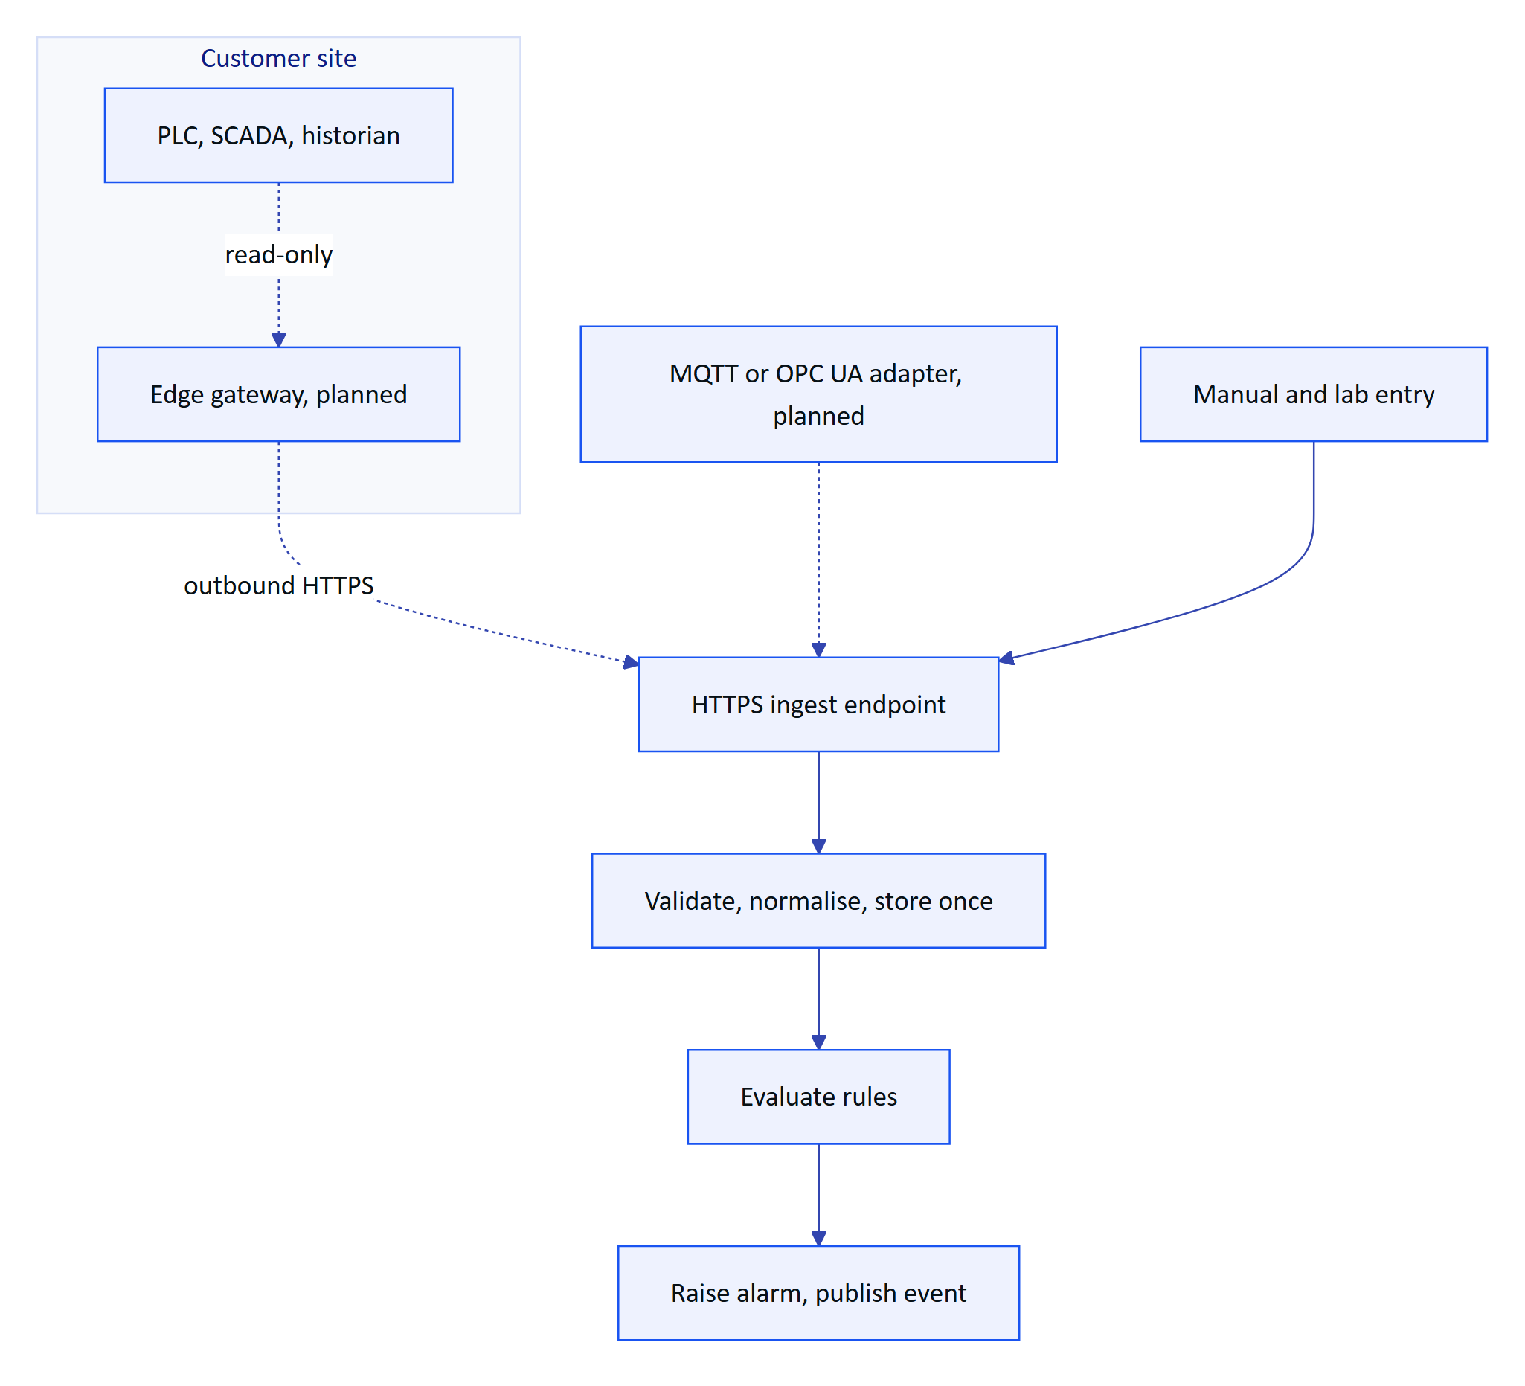
Figure 21. Telemetry from the plant to an alarm; dashed paths are planned
Realtime events (alarms, telemetry, work, devices) reach clients over Server-Sent Events opened with fetch, so the token travels in a header, never a URL. Each event is authorised per connection and carries only identifiers; clients refetch through the normal API. REALTIME_MODE=memory is immediate on a single instance; db mode fans out across instances with up to 1.5 s polling and replays from Last-Event-ID.
Table 44. Integration status
ID | Integration | Status
FR-022 | HTTPS gateway ingestion, 500 readings per call, idempotent | Built
FR-023 | Manual and lab entry with provenance | Built
FR-024 | Append-only corrections | Built
FR-033 | Realtime push of alarm events to all clients (SSE) | Built
FR-027 | MQTT and OPC UA ingestion adapters | Planned (Advanced)
FR-028 | Read-only SCADA and historian connectors | Planned (Advanced)
n/a | Edge gateway software (store and forward) | Planned; API contract Built

12.5 AI services with a human in the loop
Two features use Claude, and both are optional. Audit scanning adds a vision engine whose every value is checked against on-device OCR; the assistant calls five read-only tools inside the caller's tenant transaction, so RLS and site scope apply to every lookup. The model never sees the database. Without a key, scans keep their OCR results and the assistant uses a rules engine that never guesses. People decide what becomes a record: no document reaches verified with pending or flagged items, and approval needs a second person.
DECISION
AI adds reach, never unchecked trust (ADR-009, ADR-015). Every AI-extracted value passes human review, and the assistant has no write tools.

12.6 Platform requirements
Table 45. Platform requirements
ID | Requirement | Priority | Status
FR-003 | Refresh rotation with family revocation on reuse | P0 | Built
FR-007 | Site-scoped permissions for every role except org admin | P0 | Built
FR-008 / NFR-011 | Database-enforced tenant isolation | P0 | Built
FR-011 | SAML 2.0 and OIDC single sign-on per organization | P1 | Planned (GA)
FR-029 / NFR-030 | Synthetic data labelled and refused for customer tenants | P0 | Built
FR-050 | Pairing with short code, QR, 5-min TTL, 3 s polling | P0 | Built
FR-051 | Device tokens with rotating refresh and reuse detection | P0 | Built
NFR-001 | API read latency p95 under 300 ms in-region (target) | P0 | Partial (not measured)
NFR-002 | Realtime alarm delivery 2 s or less (target) | P0 | Built (design; not measured)
NFR-006 | Availability 99.5 % in pilot, 99.9 % at GA (targets) | P0 | Planned (measure)
NFR-007 | Horizontal scale of realtime | P0 | Built (db mode)
NFR-008 | Scheduled jobs at a cadence suitable for real data | P0 | Partial (daily on Vercel)
NFR-009 | Daily backups, point-in-time recovery, quarterly restore test | P0 | Planned
NFR-010 | CI with typecheck and tests on every change | P0 | Planned (Hardening)
NFR-013 | Rate limiting (600 per min global, 10 per min sign-in) | P0 | Built
NFR-014 | Secrets at rest encrypted or hashed | P0 | Built
NFR-017 | Data residency in India for Indian customers | P1 | Planned (GA)
NFR-018 | Independent penetration test before GA | P0 | Planned (GA)
NFR-034 | Structured logs, error tracking, uptime alerts | P1 | Planned (Pilot)
NFR-037 | Graceful degradation without the model | P0 | Built
NFR-039 | Human in the loop for every AI-extracted value | P0 | Built
NFR-040 | Model provider and region documented per tenant | P1 | Planned (GA)

RISK
On an all-Vercel topology, stale-data alarms run at most daily (NFR-008). A production plant needs a per-minute scheduler or the API in a container.

13 Non-functional requirements
Non-functional requirements apply across every product. IDs match the long PRD. Every number in the Target column is a target unless the Status column says it is built and verified by tests.
Table 46. Non-functional requirements by category
Category | ID | Requirement | Target | Status
Performance | NFR-001 | API read latency | p95 under 300 ms in-region | Partial (not measured)
Performance | NFR-002 | Realtime alarm delivery, creation to client | 2 s or less | Built (design); not measured
Performance | NFR-003 | Voice answer, end of speech to spoken answer | 3 s rules engine, 8 s model engine | Partial (not measured)
Performance | NFR-004 | OCR time per page on a mid-range phone | 15 s or less for both passes | Partial (not measured)
Performance | NFR-005 | Glasses home ready after wake | 2 s cached, fresh data within 5 s | Planned (measure)
Availability | NFR-006 | Service availability | 99.5 % monthly in pilot, 99.9 % at GA | Planned (measure)
Availability | NFR-008 | Scheduled jobs at a cadence fit for real data | Per-minute stale and pairing jobs | Partial (daily cron on Vercel)
Availability | NFR-009 | Backups and restore | Daily backups, PITR, quarterly restore test | Planned
Availability | NFR-010 | CI on every change | Typecheck, unit, API and e2e on every pull request | Planned (Hardening)
Security | NFR-011 | Tenant isolation in the database | RLS on every tenant table; app role without BYPASSRLS | Built
Security | NFR-012 | Short-lived credentials | 15-minute access tokens; rotating refresh with reuse detection | Built
Security | NFR-013 | Rate limiting | 600 per minute global; 10 per minute sign-in | Built
Security | NFR-014 | Secrets at rest | MFA secrets encrypted; tokens hashed; Android Keystore AES-256-GCM | Built
Security | NFR-018 | Independent penetration test before GA | No open high or critical findings | Planned (GA)
Privacy | NFR-015 | Camera only on explicit intent | No continuous recording or background capture | Built
Privacy | NFR-016 | Images stored only for audit documents and attachments | No other path persists camera frames | Built
Privacy | NFR-017 | Data residency in India for Indian customers | Database, storage and inference in an Indian region | Planned (GA)
Privacy | NFR-040 | Model provider and region documented per tenant | Visible in tenant settings | Planned (GA)
Accessibility | NFR-019 | Glasses text scale per profile | Scales 0.9 to 1.3 | Built
Accessibility | NFR-023 | Console and Android meet WCAG 2.2 AA | Audit before GA | Partial (not audited)
Accessibility | NFR-024 | Large touch targets for gloved use | Primary buttons 52 to 54 dp | Built
Hands-free | NFR-020 | Additive-display friendly design | Pure black renders transparent; 600 by 600 viewport | Built (verify on hardware)
Hands-free | NFR-021 | Every glasses action by six directional keys or voice | Up, down, left, right, select, back | Built
Hands-free | NFR-022 | Spoken answers are short | One or two sentences | Built
Hands-free | NFR-028 | Battery on Ray-Ban Meta | 4-hour shift with up to 20 scans | Planned (measure)
Offline | NFR-025 | Inspection responses survive connectivity loss | Queue with idempotent replay | Built
Offline | NFR-026 | Last context and SOPs readable offline | Shown as cached, never as live | Built
Offline | NFR-027 | Android offline outbox | Phone actions queue and replay | Planned (GA)
AI quality | NFR-035 | Assistant uses only values from tools in the conversation | Zero numbers absent from tool results | Built (prompt and tool design)
AI quality | NFR-036 | Assistant states reading age and stale or missing data | Every answer with a value | Built
AI quality | NFR-037 | Graceful degradation without the model | Rules engine and OCR-only fallback | Built
AI quality | NFR-039 | Human in the loop for every AI-extracted value | No verified document with pending or flagged items | Built

Table 47. AI and OCR quality targets for the pilot (targets, not measurements)
Measure | Target | How it will be measured
Fields where independent engines agree | 90 % or more on typed forms | Agreement score; pilot sample of 200 pages
Fields a reviewer corrects | Under 5 % | Corrected over reviewed fields
Vision false confidence | Under 0.5 % | Blind re-check of 100 approved documents
Assistant answers with facts | 85 % or more | Intent logging on /assistant/ask
Answers with a number not in the facts | 0 | Automated check on logged answers

NOTE
The security-critical paths are covered by 67 passing automated tests (26 domain, 41 API, local run on 22 October 2026) plus 4 Playwright journeys. Performance, availability and battery numbers have not yet been measured; measuring them is part of the pilot entry criteria.

14 Release plan and milestones
The MVP shipped between 14 and 22 October 2026: API, console, glasses app and simulator, pairing, UI profiles, audit scanning, voice, demo mode and the native Android app in code. The plan below sequences the rest. Dates are a plan, not a commitment, and depend on the dependencies and open questions in later sections.
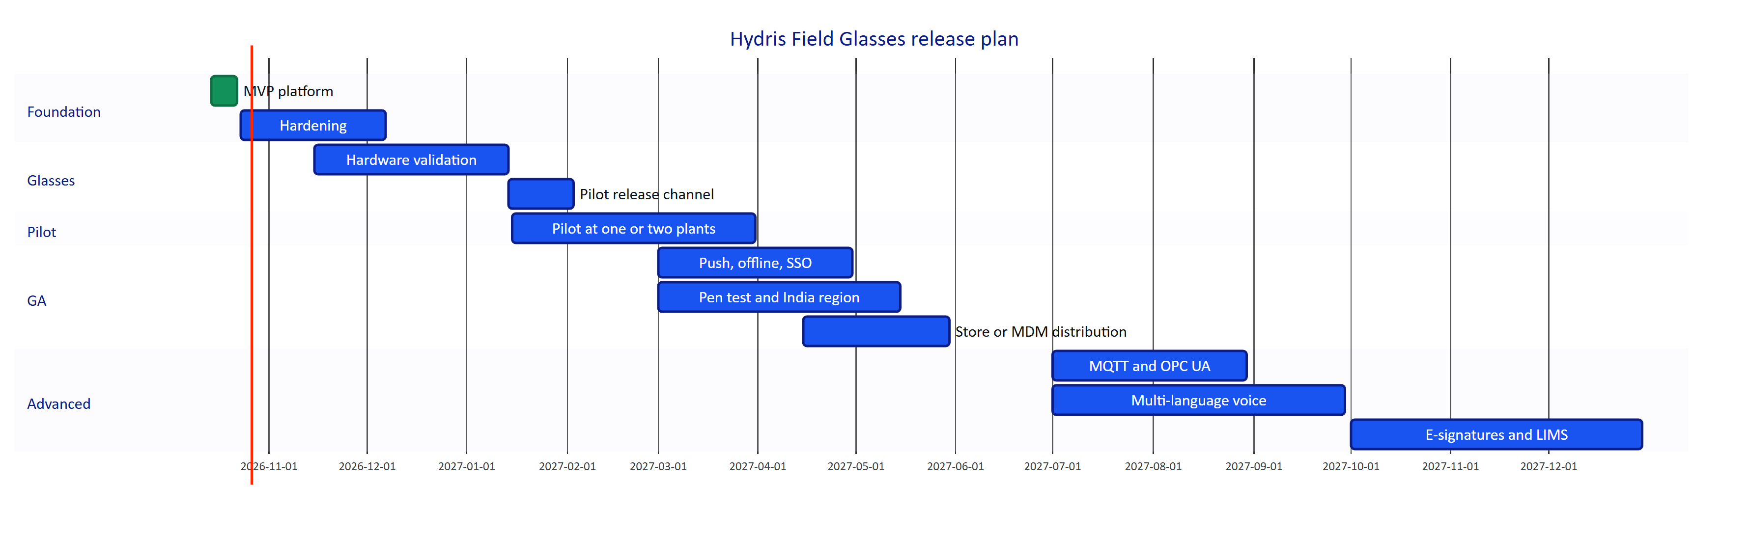
Figure 22. Release plan, Q4 2026 to Q4 2027 (plan, indicative dates)

14.1 Phase entry and exit criteria
Table 48. Release phases with entry and exit criteria
Phase | When (plan) | Entry criteria | Scope | Exit criteria
MVP | Done, October 2026 | None | Platform core, all products in code | Live demo; 67 tests passing
Hardening | Q4 2026 | MVP on main | Email (FR-086), CI (NFR-010), job cadence (FR-035, NFR-008), Android fixes (FR-094, FR-099), page images to object storage, observability (NFR-034) | All Must requirements for pilot Built or with an agreed workaround
Hardware validation | Q4 2026 to Q1 2027 | DAT Developer Mode access; test glasses on hand | Camera, capture button, speech, registration (FR-055, FR-056, FR-057, FR-074); battery (NFR-028) | Every glasses requirement Built, or descoped with a phone fallback
Pilot | Q1 2027 | Hardening exit; signed pilot contract; site camera policy agreed | One or two Indian ETPs or STPs, 10 to 30 operators, gateway ingestion, compliance summary (FR-120), escalation (FR-037), Android inspections (FR-044) | KPI baselines captured; targets met or explained; customer sign-off
GA | Q2 2027 | Pilot exit | FCM push (FR-034), offline outbox (FR-098), SSO (FR-011), India region (NFR-017), pen test (NFR-018), recurring schedules (FR-047), Play or MDM | Store or MDM release approved; security review passed
Advanced | H2 2027 onwards | GA | MQTT and OPC UA (FR-027), SCADA connectors (FR-028), multi-language voice (FR-073), e-signatures (FR-068), native glasses display, LIMS, iOS | Driven by customer demand

14.2 Pilot exit criteria
The pilot is judged on evidence, not on feature count. It exits successfully when all of the following hold:
- ☐ KPI baselines are captured for paper rounds before go-live and for Hydris during the pilot.
- ☐ Pilot targets are met or each miss is explained with a remedy: 70 % weekly active operators, 95 % on-time rounds, under 5 minutes to acknowledge critical and high alarms, under 24 hours capture to approval.
- ☐ Zero hallucinated numbers in logged assistant answers and zero cross-tenant incidents.
- ☐ Every glasses feature used in the pilot runs on physical Ray-Ban Meta glasses or has a working phone fallback.
- ☐ Availability at or above the 99.5 % pilot target (NFR-006).
- ☐ The customer signs off and states whether the regulator accepts the Hydris PDF as a primary record (Q4).
DECISION
Every glasses feature must work on the phone first. This decouples the pilot from both hardware risk and Meta's distribution timeline.

15 Dependencies, assumptions and constraints
Table 49. Dependencies, assumptions and constraints
Type | Item | Impact if it fails | Fallback or response
Dependency | Meta AI app (com.facebook.stella) for pairing, registration, permissions and firmware | Glasses features unavailable | Phone camera and microphone paths
Dependency | Meta Wearables DAT 1.0.1 and Developer Mode | Cannot reach the glasses | Phone paths; Developer Mode for the pilot
Dependency | Wearables Developer Center registration | Cannot distribute beyond test devices | Apply early; pilot in Developer Mode
Dependency | Vercel hosting, cron and Blob storage | Hosted service outage; daily cron only | Container deployment (Docker, Render blueprint)
Dependency | Managed Postgres (Neon or similar) | Outage | Point-in-time recovery; PGlite for local and demo
Dependency | Anthropic API for assistant and vision | Degraded answers, no vision | Rules engine and OCR-only extraction (Built)
Dependency | Google ML Kit text recognition | Lower OCR quality on Android | Tesseract.js path in the web app
Dependency | Email provider (to be chosen) | Invitations and resets do not arrive | Admin copies links from mail_outbox
Assumption | Pilot plants have an HTTPS gateway or OCEMS analyzer that can push readings | No live telemetry | Manual and lab entry
Assumption | Operators carry an Android 12 or later phone (min SDK 31) | Android app cannot install | Glasses web app in phone layout
Assumption | Customers allow camera glasses in agreed zones | Scan disabled on site | UI profile disables Scan; phone scanning
Constraint | Read-only towards the plant | No control actions | By design (P1)
Constraint | English UI and voice until Advanced | Limited reach for non-English speakers | Multi-language voice Planned (FR-073)
Constraint | No iOS before GA | iPhone users excluded | Decision at GA planning (Q5)

16 Risks and mitigations
Table 50. Product risks with likelihood, impact and mitigation
ID | Risk | Likelihood | Impact | Mitigation | Owner
R1 | Meta DAT publishing stays gated | Medium | High | Pilot in Developer Mode; phone paths ship independently; apply early | Product
R2 | Meta AI app behaviour changes | Medium | Medium | Onboarding checklist; Glasses screen shows link state and connection log | Mobile
R3 | Glasses paths fail on real hardware | Medium | High | Hardware matrix before pilot; phone fallback on every feature | Mobile, QA
R4 | Email not wired | High | Medium | FR-086 in Hardening; interim admin copy of links | Platform
R5 | Serverless cron runs once a day | High | High | Per-minute cron or container host; NFR-008 | Platform
R6 | No CI | Medium | Medium | NFR-010 in Hardening | Platform
R7 | Android Resolve fails without a note | High | Medium | FR-094 fix in Hardening | Mobile
R8 | LLM availability, cost or residency objections | Medium | High | Rules and OCR-only modes; region-pinned provider; NFR-040 | Product
R9 | Camera glasses not accepted on site; bystander privacy | Medium | Medium | Camera on intent only; UI profile can disable Scan; site policy in contract | Product
R10 | Regulators do not accept Hydris PDFs as primary records | Medium | High | Original scan inside every PDF; e-signatures (FR-068); early SPCB conversations | Product
R11 | Device refresh token in browser storage on the web glasses app | Low | Medium | Native app with Keystore is the pilot path | Security
R12 | Audit page images stored in the database | Medium | Low | Move to object storage in Hardening | Platform

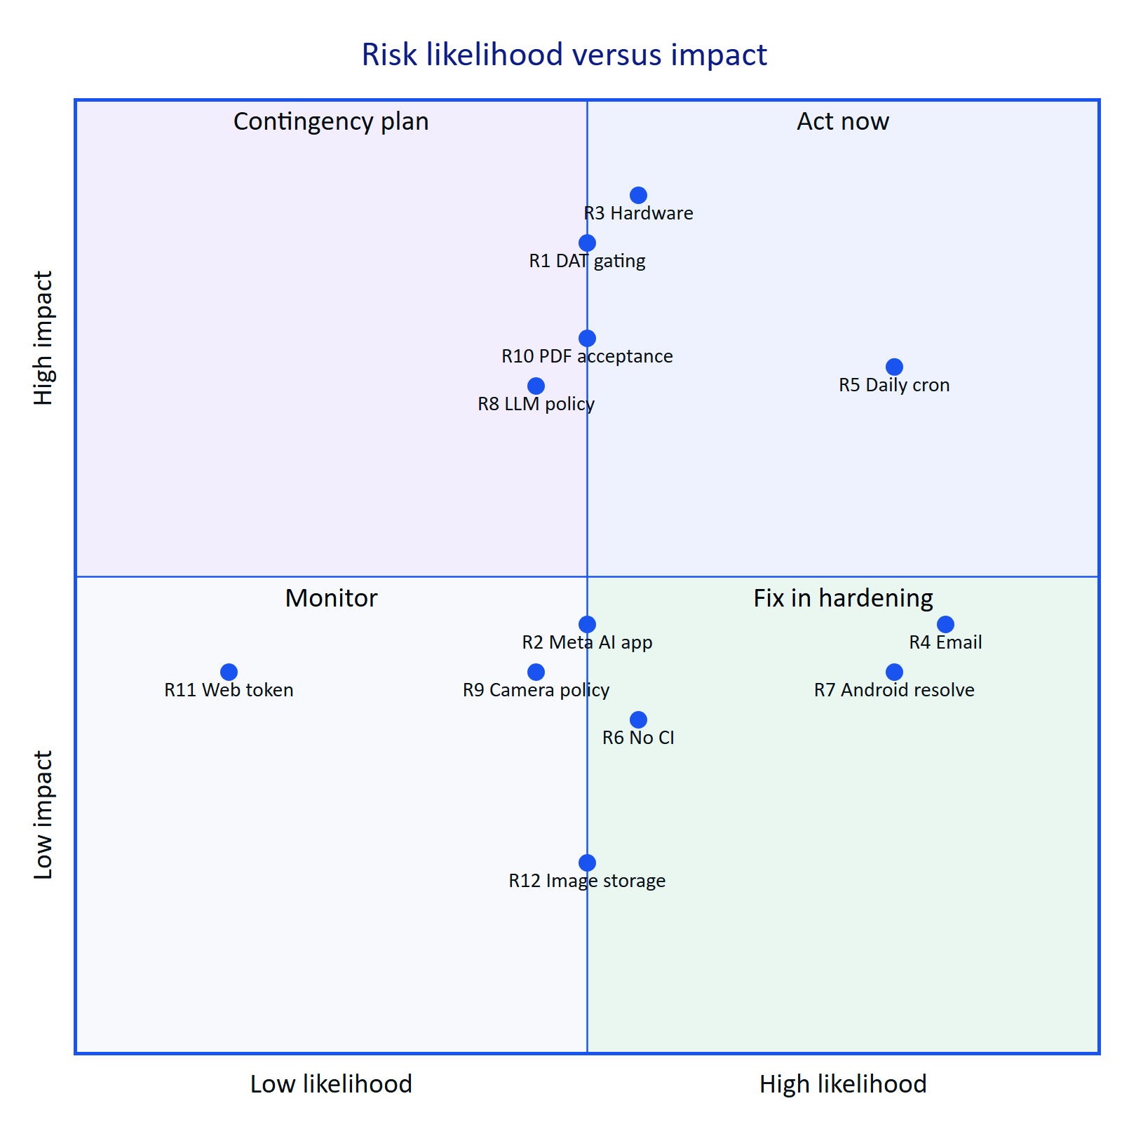
Figure 23. Risk map by likelihood and impact (product team estimate)
RISK
The largest schedule risk is R3 combined with R1: everything unique to Hydris on glasses (camera scanning, capture button, glasses microphone) is code-complete but unproven on hardware, and distribution beyond Developer Mode is in Meta's hands. The phone-first decision protects the pilot.

17 Open questions and decisions
Table 51. Open questions with owner and due point
ID | Question | Owner | Due
Q1 | Is India among Meta's supported countries for full DAT capabilities and Developer Center access? Written confirmation needed | Product | Before hardware validation
Q2 | When do DAT store submissions open, and what review does an unlisted enterprise app need? | Product | GA planning
Q3 | Will pilot customers allow camera glasses in their plants, and in which zones? | Customer success | Pilot contract
Q4 | Which regulators accept a Hydris PDF as the primary record rather than a scanned copy? | Product, pilot customer | Pilot exit
Q5 | Is an iOS app needed for pilot or GA customers? | Product | GA planning
Q6 | Must LLM inference run in India for Indian customers, and through which provider? | Security | Before enabling the model for a customer
Q7 | Does acknowledgement on the glasses count as the assigned operator or the device in compliance reports? | Product, compliance | Pilot
Q8 | What consent-limit data model does the compliance summary (FR-120) need? | Product | Pilot
Q9 | Which email provider meets deliverability and residency needs? | Platform | Hardening
Q10 | Should the handover summary (FR-122) use the model or deterministic templates? | Product | GA planning

Table 52. Decisions recorded in this PRD
Decision | Rationale
Hydris is read-only towards the plant | Keeps Hydris outside the control-system safety case
The pilot runs on the native Android app, not the WebView bridge | Keystore token storage, on-device OCR, direct DAT access
Every glasses feature works on the phone first | Decouples the pilot from hardware and Meta distribution risk
Rules engine and OCR-only modes are first-class | Pilots can run without the model until a tenant consents to processing
Approval needs a second, different person | Records stand up to an audit (P5)

18 Appendix

18.1 Glossary
Table 53. Terms used in this document
Term | Meaning
ETP, STP, WTP, CETP | Effluent, sewage, water and common effluent treatment plant
CPCB, SPCB | Central and State Pollution Control Boards in India
OCEMS | Online continuous effluent and emission monitoring system
Consent to operate | SPCB permission that sets a plant's discharge limits
Measurand | A quantity a sensor measures, such as pH or dissolved oxygen
Freshness | Live, delayed, stale or no data, from a sensor's expected interval
Deadband, on-delay | Hysteresis band and persistence time that stop alarms chattering
RLS | Row-level security in Postgres, used for tenant isolation
SSE | Server-sent events, the realtime channel to clients
DAT | Meta Wearables Device Access Toolkit
Meta AI app | Meta's companion app that pairs, registers and updates the glasses
UI profile | Versioned configuration of what a pair of glasses shows and allows
Four eyes | A second, different person approves what the first verified
Agreement | Whether independent OCR and vision readings of a value match
Demo mode | Zero-configuration deployment with a synthetic tenant
Built, Partial, Planned | On main and exercised; partly built or not validated; not yet in the repository

18.2 Related documents
Table 54. Related documents in docs/product/
Document | What it covers
PRD.md | Full requirements with every FR and NFR, acceptance criteria and priorities
book/ | The product book: one compact PRD per product
ARCHITECTURE.md | Containers, flows, tenancy and token model
DATA_MODEL.md | Tables, enums, RLS and retention
API_REFERENCE.md | Routes, payloads, errors and limits
MOBILE_APP_SPEC.md | Hydris Field Android specification
GLASSES_INTEGRATION.md | Ray-Ban Meta and DAT capability matrix and flows
DESIGN_SYSTEM.md | Tokens, heads-up display and console patterns
SECURITY_PRIVACY.md | Controls, threat model and data handling
DEPLOYMENT.md | Topologies, environment and distribution
QA_TEST_PLAN.md | Test strategy, hardware matrix and journeys
OPERATIONS_RUNBOOK.md | Onboarding, incidents, backups and support
ROADMAP.md | Horizons, timeline and future products

